

CAPSTONE PROJECT REPORT
Report 3 – Software Requirement Specification

– Ho Chi Minh, September 2026 –
DroneOps Intelligence | FA26SE238 | GFA26SE167
Version 1.0 — 15 September 2026

Table of Contents

Table of Contents 2
I. Record of Changes 4
II. Software Requirement Specification 5
1. Product Overview 5
1.1 Source Basis and Specification Conventions 5
1.2 System Context 6
2. User Requirements 7
2.1 Actors 7
2.2 Use Cases 7
2.2.1 Diagram(s) 7
2.2.2 Descriptions 11
3. Functional Requirements 13
3.1 System Functional Overview 13
3.1.1 Screens Flow 13
3.1.2 Screen Descriptions 13
3.1.3 Screen Authorization 14
3.1.4 Non-Screen Functions 15
3.1.5 Entity Relationship Diagram 15
3.1.6 Mainflow Activity Diagrams 18
3.1.7 Lifecycle Diagrams 22
3.2 FE-01 — UAV and Operator Management 23
3.2.1 Sign in and sign out (UC-01) 23
3.2.2 Manage UAV records (UC-02) 24
3.2.3 Manage operators and assignments (UC-03) 25
3.2.4 Configure operational restrictions (UC-04) 25
3.3 FE-02 — Mission Planning and Management 26
3.3.1 Create a mission plan (UC-05) 26
Screen layout placeholder — SHOT-07 / SCR-07 27
3.3.2 Edit a route and mission version (UC-06) 27
3.3.3 View or cancel a mission plan (UC-07) 27
3.4 FE-03 — Mission Approval Workflow 28
3.4.1 Submit a mission for validation (UC-08) 28
3.4.2 Approve or reject a mission (UC-09) 29
3.4.3 Review approval history (UC-10) 29
3.5 FE-04 — Geofence and Flight Path Validation 30
3.5.1 Validate waypoints and route segments (UC-11) 30
3.5.2 Review mapped validation results (UC-12) 30
3.6 FE-05 — MAVLink Telemetry Integration 31
3.6.1 Provide and ingest telemetry (UC-13) 31
3.7 FE-06 — Real-Time Mission Monitoring 31
3.7.1 Monitor an active mission (UC-14) 31
3.8 FE-07 — Operational Alert and Incident Detection 32
3.8.1 Detect incidents and deliver alerts (UC-15) 32
Screen layout placeholder — SHOT-11 / SCR-11 33
3.9 FE-08 — Incident Management and Post-Flight Analysis 33
3.9.1 Review and manage an incident (UC-16) 33
3.9.2 Finalize a flight and generate a post-flight report (UC-17) 34
3.9.3 Review mission history and post-flight results (UC-18) 34
3.10 FE-09 — AI-Assisted Mission Decision Support 35
3.10.1 Request an AI-assisted risk assessment (UC-19) 35
3.10.2 Review AI advice and supplied context (UC-20) 36
3.11 FE-10 — Mission and Operational Dashboard 36
3.11.1 View an operational dashboard (UC-21) 36
3.11.2 Review operational analytics (UC-22) 37
4. Non-Functional Requirements 38
4.1 External Interfaces 38
4.2 Quality Attributes 38
4.2.1 Usability 39
4.2.2 Reliability 39
4.2.3 Performance 39
4.2.4 Security and Privacy 40
4.2.5 Maintainability and Testability 40
4.2.6 Compatibility and Recovery 40
5. Requirement Appendix 41
5.1 Business Rules 41
5.2 Common Requirements 41
5.3 Application Messages List 42
5.4 Open Decisions and Assumptions 42
5.5 Requirements Traceability 43
5.6 Screenshot Insertion Checklist 43

I. Record of Changes
Date | A*  M, D | In charge | Change Description
14/09/26 | A | Project team | Added API-based AI, existing context/swimlanes and new requirements diagrams. Added screenshot placeholders and a decision register.
16/09/26 | M | Project team | Updated mainflow and related decision ownership: NghiaHQ MF1, KhanhGNG MF2, DucDDA MF3, ThongLQ MF4. Existing functions

A = Added; M = Modified; D = Deleted.

II. Software Requirement Specification

1. Product Overview
DroneOps Intelligence is a mission-operations platform for managing UAVs, operators, mission plans and versions, configured flight restrictions, live telemetry, incidents and post-flight evidence. It supports a Web application and a planned Operator mobile client. This SRS specifies the shared behavior and a proposed Web screen organization; mobile coverage is an open decision (D-09).
The platform checks mission routes against configured restrictions before Operations Manager approval. During execution, a MAVLink-compatible UAV/autopilot or simulator supplies telemetry through an integration gateway. The platform monitors state, detects configured abnormal events, stores evidence and produces post-flight reports. A configured external OpenAI or Gemini API supplies advisory mission summaries, potential risks and precautions; users retain responsibility for review and approval.
Scope exclusions: no low-level navigation, stabilization, autonomous flight execution or replacement of GCS/autopilot software. No k-NN/vector retrieval, custom model training or autonomous AI approval is included. Restriction checks cover configured data only; they do not certify compliance with unprovided restrictions.
Flow | Purpose | Primary owner | Features
MF1 | Mission Planning & Pre-flight Validation | NghiaHQ | FE-02/03/04
MF2 | Real-Time Monitoring & Incident Management | KhanhGNG | FE-05/06/07/08/10
MF3 | Post-Flight Analysis & Mission History | DucDDA | FE-08/10
MF4 | AI-Assisted Mission Risk Assessment | ThongLQ | FE-09/10

1.1 Source Basis and Specification Conventions
Source | Use in this SRS
SRC-01 — Report1_Project Introduction.docx | Ten feature definitions, target users and scope exclusions. FE-09, product vision and current user direction establish external AI API scope.
SRC-02 — Mainflows, Actors.docx | Four mainflow names and participation.
SRC-03 — Existing context and swimlane .drawio / PNG files | System boundary and four operational workflows, reused without altering the user-edited sources.
SRC-04 — Report2_Project_Management_Plan.docx and Project Schedule | Four-member ownership and council-aligned requirements/design delivery; these do not prove implementation is complete.
SRC-05 — Supplied Report 3 template | Section structure, actor/UC tables, screen flow/authorization, non-screen functions, ERD, function details, interfaces, quality attributes and appendices.
A requirement marked D-xx depends on the decision register in section 5.4. Items identified as requiring confirmation remain subject to the decision register. “Shall” expresses the intended software behavior of this specification. Screen names and paths are proposed navigation labels, not verified application URLs. No application source or running UI was supplied in the project folder.

1.2 System Context
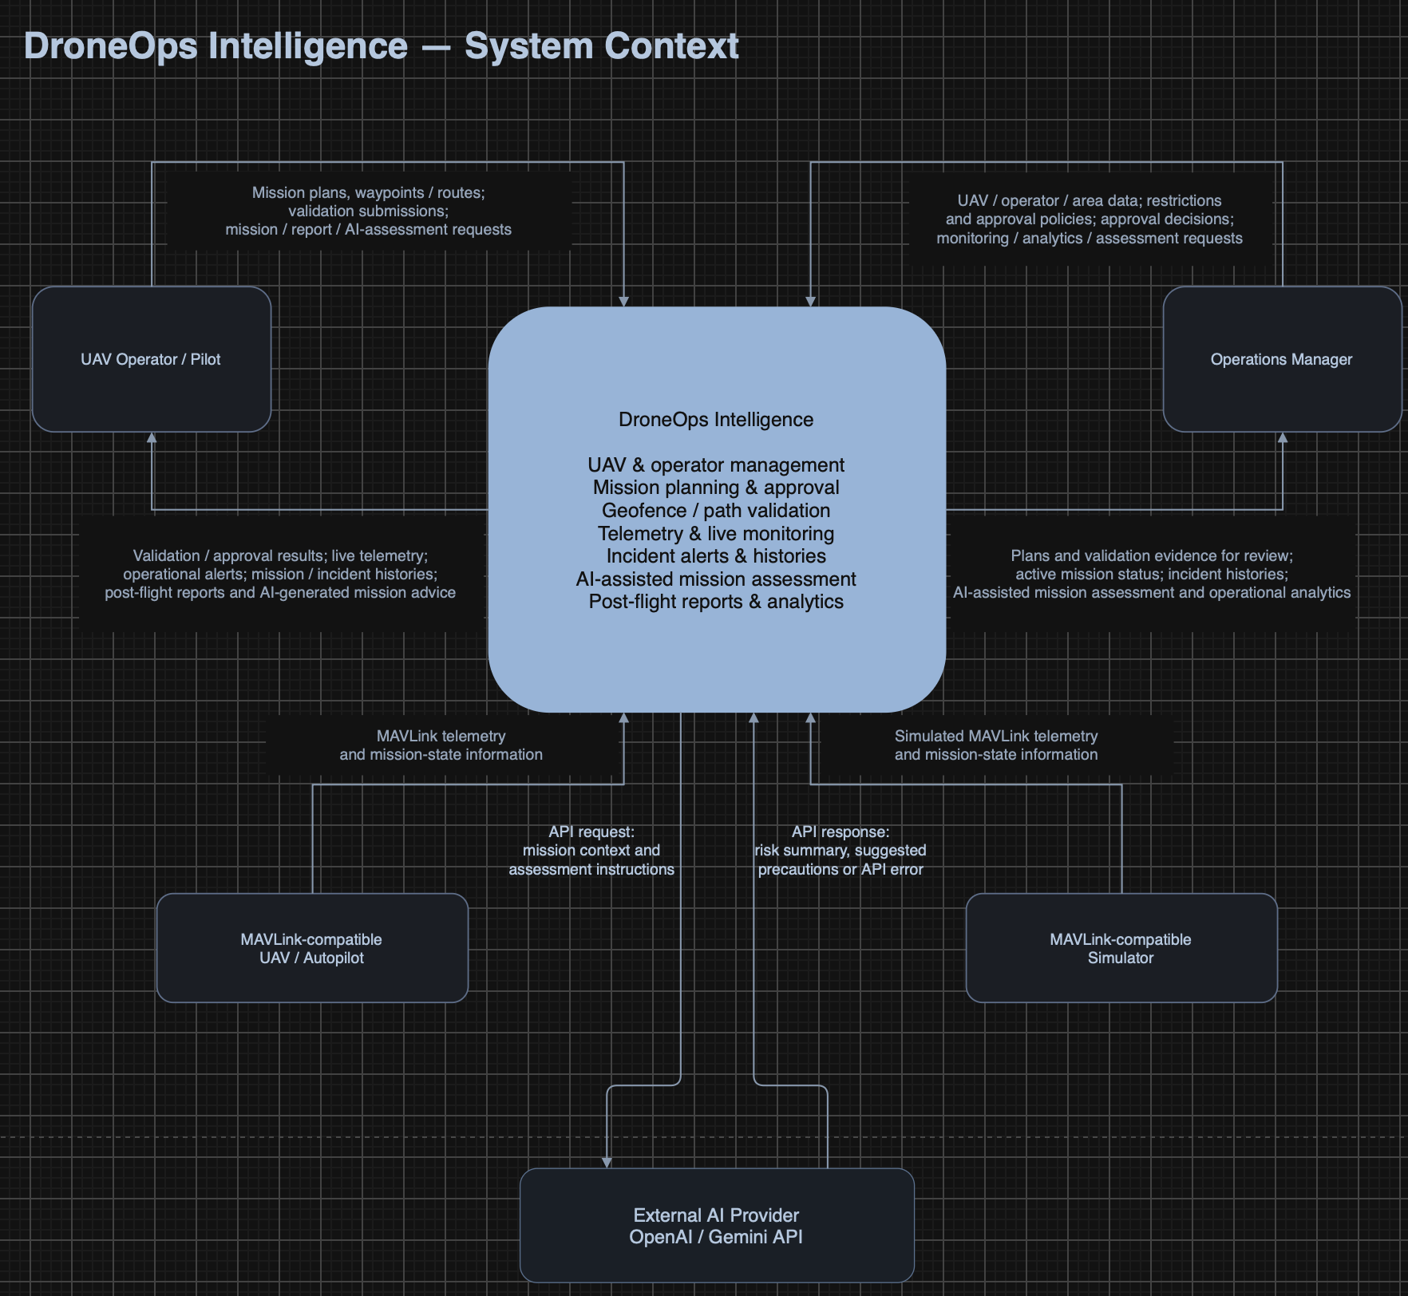
Figure 1. System context diagram.

2. User Requirements

2.1 Actors
ID | Actor | Responsibilities
ACT-01 | UAV Operator / Pilot | Create/revise/submit assigned mission plans; review validation, monitoring, alerts, history and AI advice; Web and planned mobile interaction.
ACT-02 | Operations Manager | Manage UAV/operator/area data and restrictions; review and approve/reject missions; monitor operations and review reports/AI advice. Detailed record/edit scope is proposed in D-01/D-03.
ACT-03 | UAV/Autopilot or Simulator | Supply MAVLink telemetry and configured mission-state events. These are alternative compatible data sources; no human login is required.
ACT-04 | External AI Provider | Return advisory content or API errors for authorized backend requests to the configured OpenAI or Gemini service.

2.2 Use Cases

2.2.1 Diagram(s)
The following five views describe the same system boundary. Shared management is not a fifth mainflow. Actor associations express participation, not unrestricted write permissions; section 3.1.3 controls individual actions. UC-11 is included by UC-08. Other runtime dependencies are described in the function specifications rather than misrepresented as UML include relations.
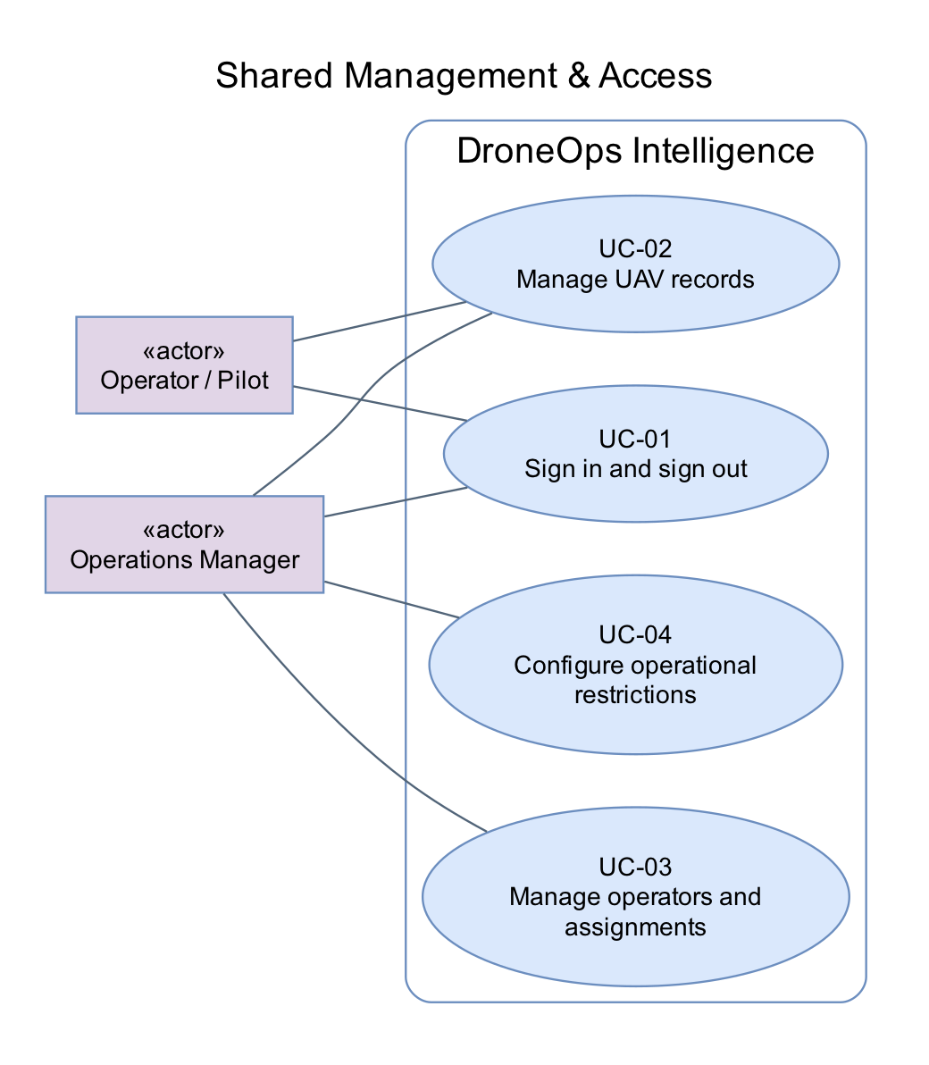
Figure 2. Shared Management & Access
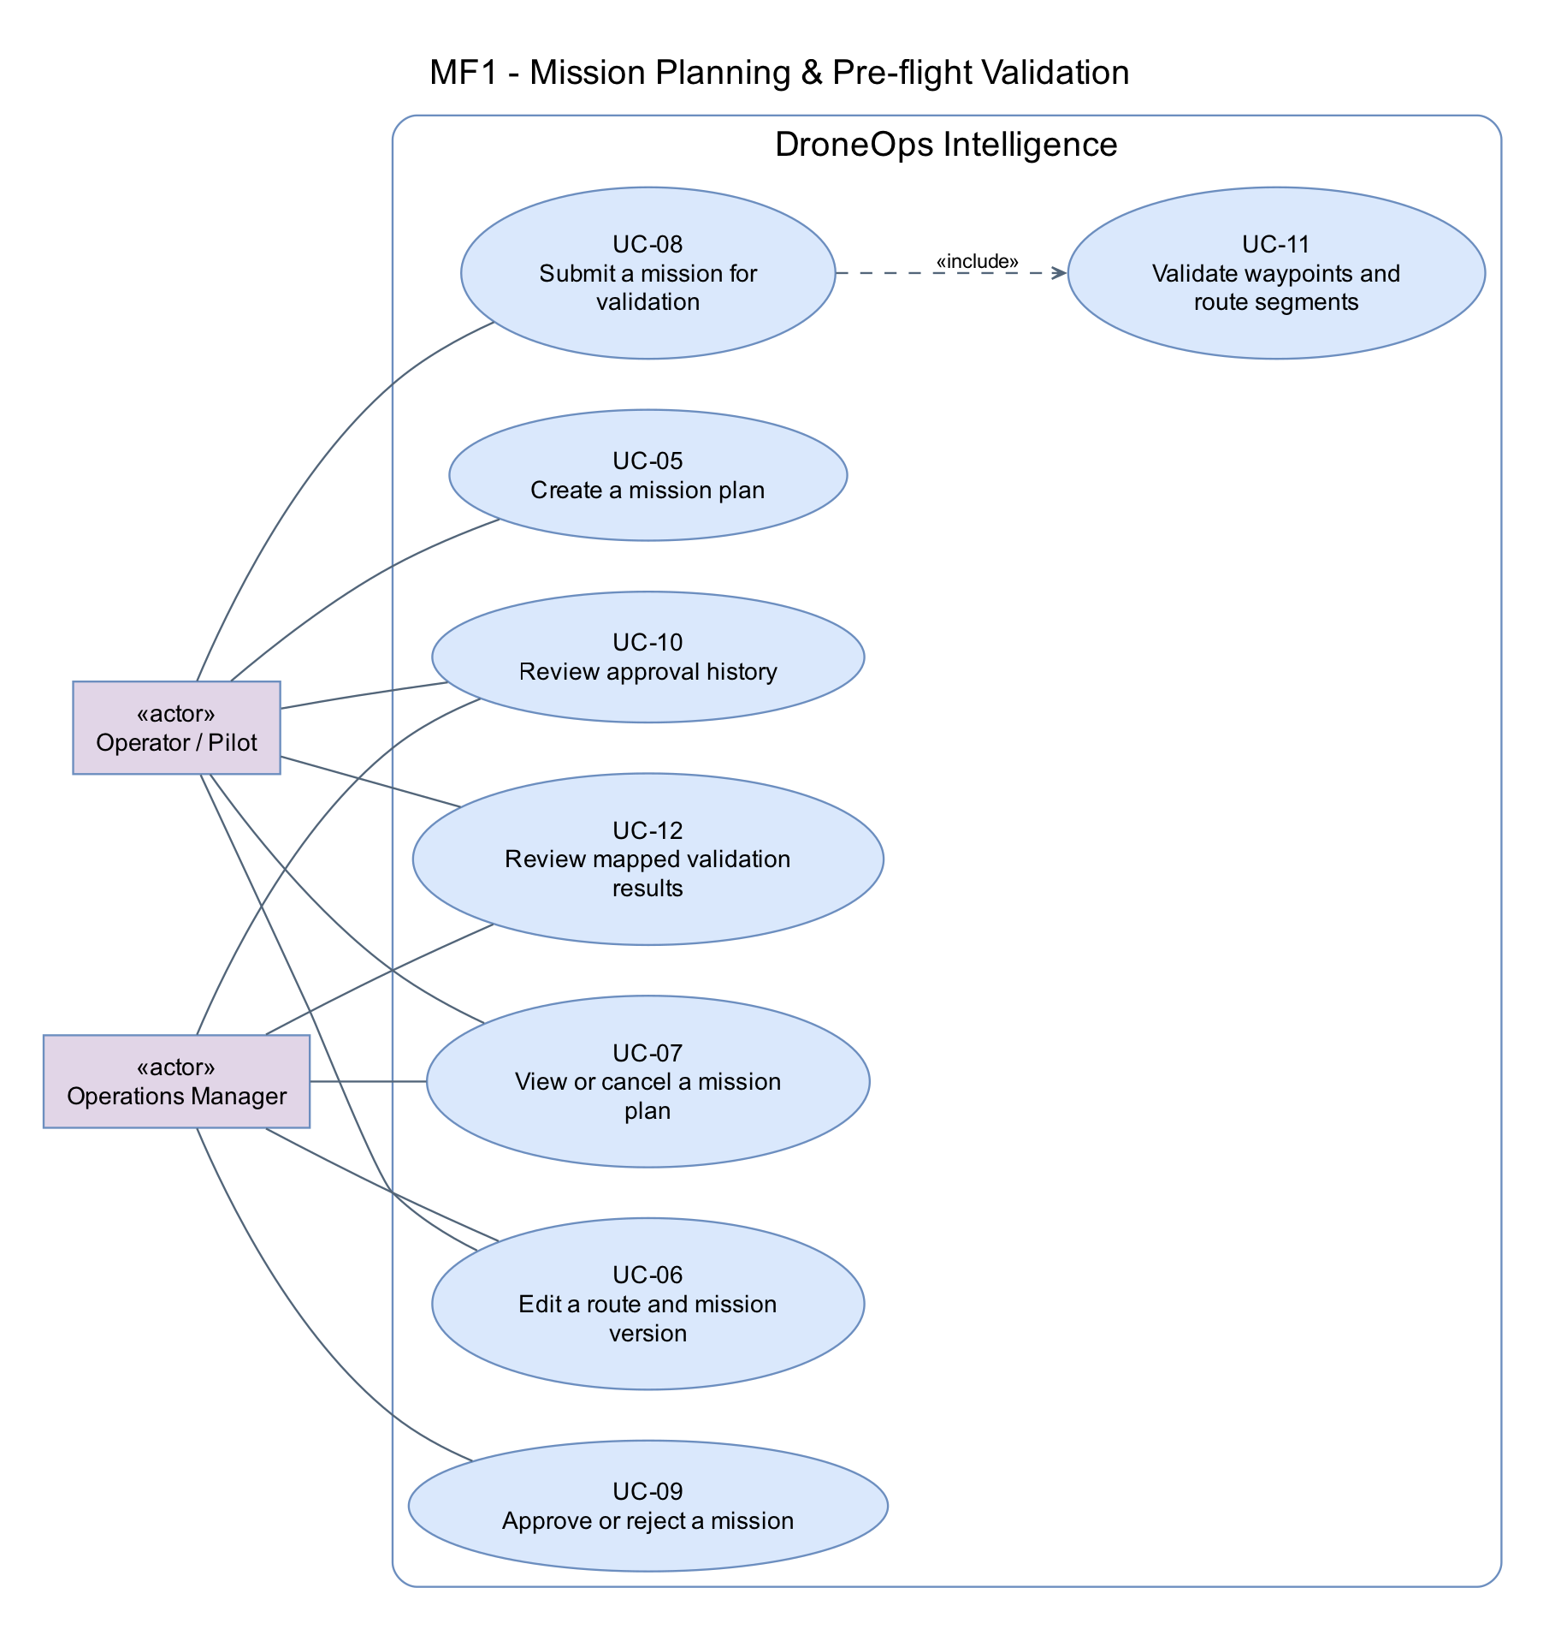
Figure 3. MF1 - Mission Planning & Pre-flight Validation
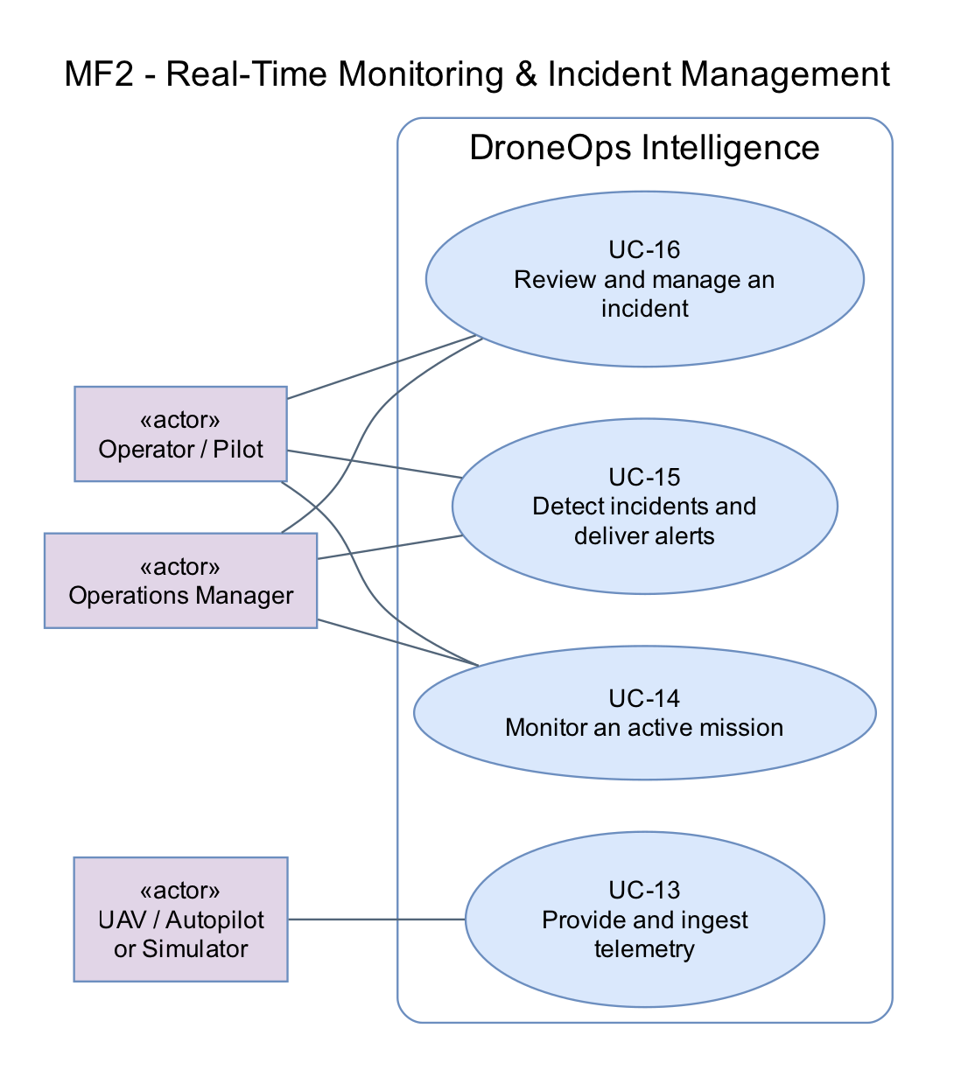
Figure 4. MF2 - Real-Time Monitoring & Incident Management
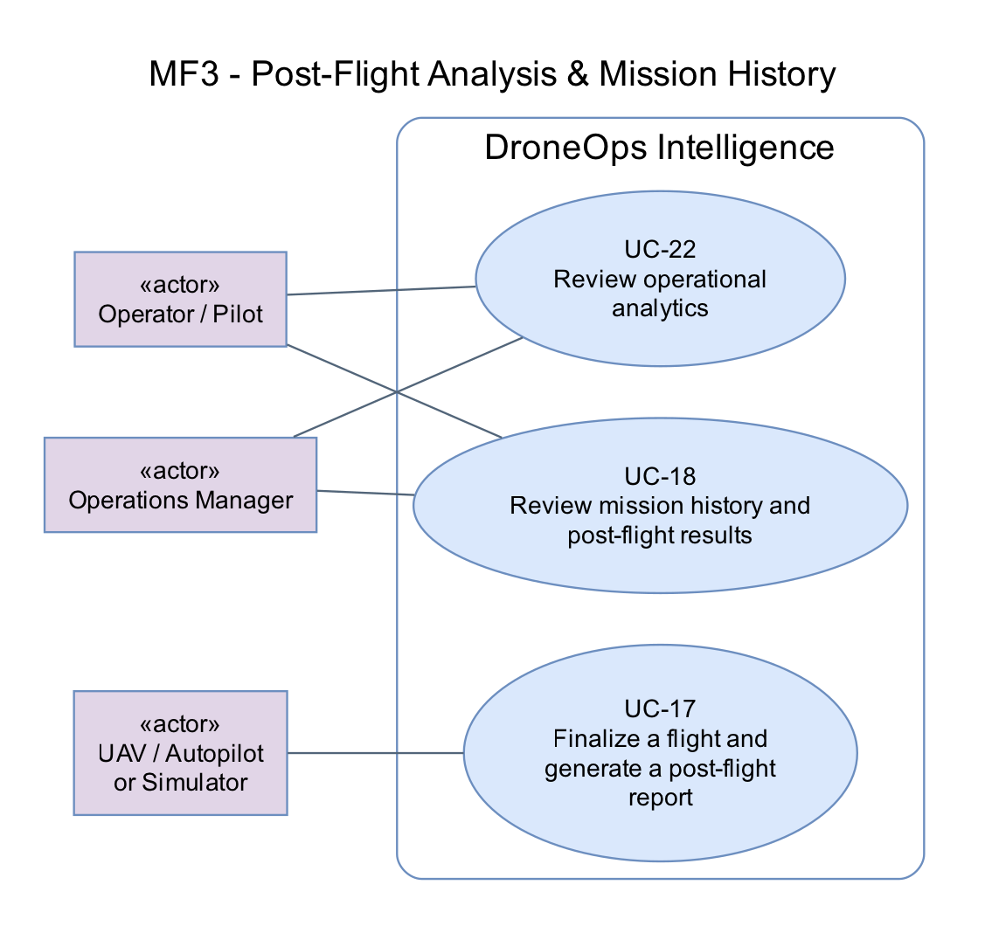
Figure 5. MF3 - Post-Flight Analysis & Mission History
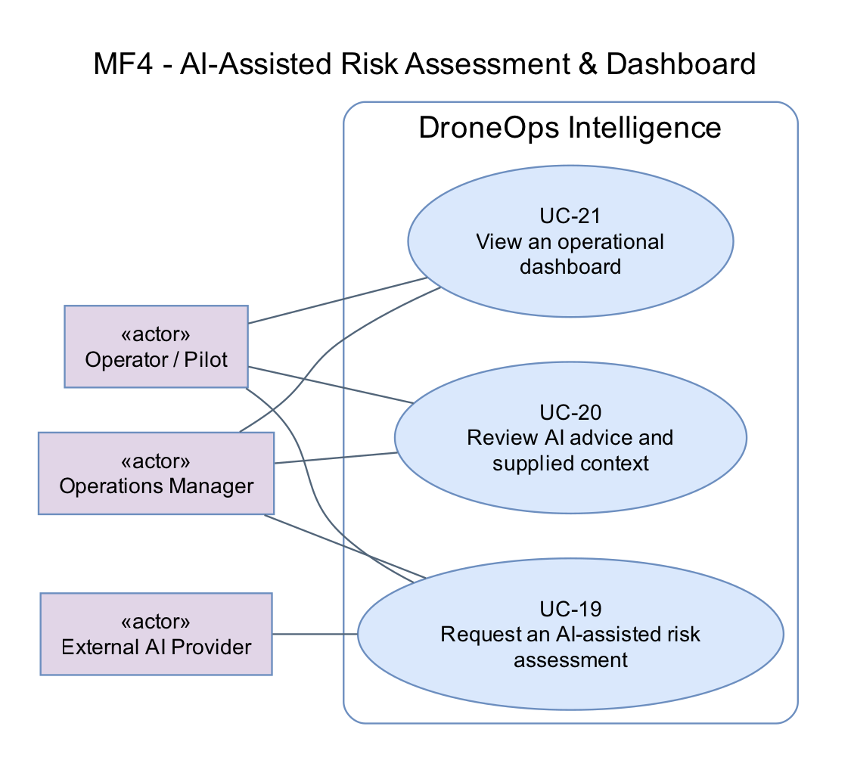
Figure 6. MF4 - AI-Assisted Risk Assessment & Dashboard

2.2.2 Descriptions
ID | Use Case | Actors | Outcome
UC-01 | Sign in and sign out | Operator; Manager | Authenticated role-scoped session or signed-out state.
UC-02 | Manage UAV records | Manager; Operator (view only) | Saved UAV record and recorded actor/time of change.
UC-03 | Manage operators and assignments | Manager | Updated operator/assignment records.
UC-04 | Configure operational restrictions | Manager | Versioned operational restrictions available to validation.
UC-05 | Create a mission plan | Operator | Draft mission owned by the creator.
UC-06 | Edit a route and mission version | Operator; Manager (proposed scope) | Saved version with author/time; earlier reviewed evidence retained.
UC-07 | View or cancel a mission plan | Operator; Manager | Mission details shown or planning record cancelled with audit evidence.
UC-08 | Submit a mission for validation | Operator | Validated version pending manager review or actionable validation failure.
UC-09 | Approve or reject a mission | Manager | Immutable decision linked to the reviewed version; Approved or Rejected state.
UC-10 | Review approval history | Operator; Manager | Traceable approval history.
UC-11 | Validate waypoints and route segments | Operator (via submission) | Version-linked validation result and map evidence.
UC-12 | Review mapped validation results | Operator; Manager | User can locate violations and decide whether to edit/resubmit.
UC-13 | Provide and ingest telemetry | UAV/Autopilot or Simulator | Stored telemetry and updated UAV/mission projection without flight-control commands.
UC-14 | Monitor an active mission | Operator; Manager | Real-time operational view with explicit freshness.
UC-15 | Detect incidents and deliver alerts | UAV/Simulator (data source); Operator; Manager | Persisted incident and available in-app alert; no autonomous control action.
UC-16 | Review and manage an incident | Operator; Manager | Reviewed incident with append-only status history.
UC-17 | Finalize a flight and generate a post-flight report | UAV/Autopilot or Simulator (completion source) | Completed flight history and available or explicitly failed report.
UC-18 | Review mission history and post-flight results | Operator; Manager | User reviews recorded flight evidence and report.
UC-19 | Request an AI-assisted risk assessment | Operator; Manager | Available assessment or explicit failed status; no change to mission approval.
UC-20 | Review AI advice and supplied context | Operator; Manager | Human-reviewed advisory evidence, with manual mission review still available.
UC-21 | View an operational dashboard | Operator; Manager | Role-scoped operational overview.
UC-22 | Review operational analytics | Operator; Manager | Explainable aggregate view backed by recorded data.

3. Functional Requirements

3.1 System Functional Overview
Feature IDs FE-01 to FE-10 preserve Report 1 traceability. UC IDs identify user/system interactions. Each detailed function defines FR-xx.1 (normal behavior), FR-xx.2 (validation and exceptional behavior), and FR-xx.3 (persisted/displayed outcome). Screens may support multiple features; internal processing is listed separately.

3.1.1 Screens Flow
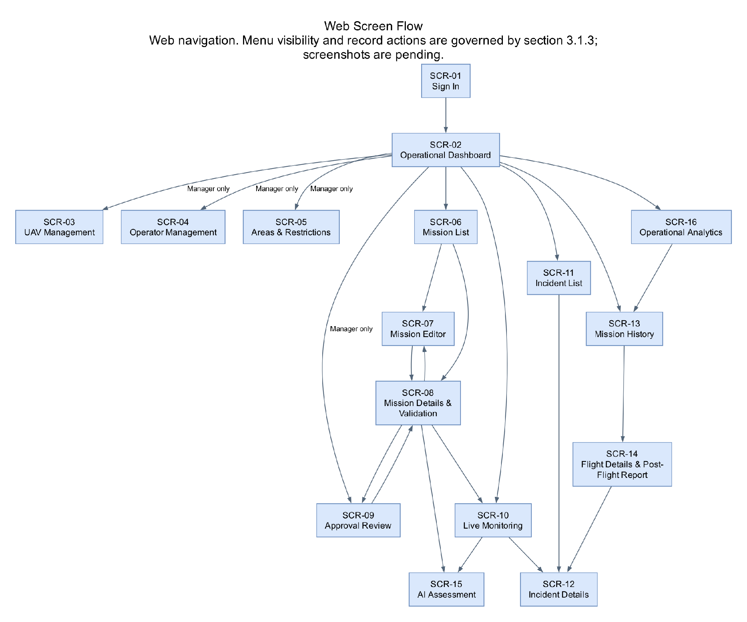
Figure 7. Web screen flow. Role and action authorization applies at every navigation and API entry point.

3.1.2 Screen Descriptions
ID | Feature | Screen | Description / Navigation
SCR-01 | FE-01 | Sign In | Login page before authentication. Form and invalid-credential message.
SCR-02 | FE-10 | Operational Dashboard | Dashboard. Summary cards, active missions, recent alerts and navigation.
SCR-03 | FE-01 | UAV Management | Management > UAVs. List plus Add/Edit UAV form.
SCR-04 | FE-01 | Operator Management | Management > Operators. Operator list, account status and assignment form.
SCR-05 | FE-01/04 | Areas & Restrictions | Management > Operational Areas & Restrictions. Map, polygon editor, restriction type and altitude fields.
SCR-06 | FE-02 | Mission List | Missions. Search/filter, status column and New Mission action.
SCR-07 | FE-02 | Mission Editor | Missions > New Mission or Details > Edit. Metadata, UAV/operator selection, ordered waypoint list and route map.
SCR-08 | FE-02/03/04 | Mission Details & Validation | Missions > select mission. Overview, versions/decisions and validation map with failing segments.
SCR-09 | FE-03 | Approval Review | Approvals > pending mission. Submitted version, evidence, Approve/Reject and rejection-reason dialog.
SCR-10 | FE-05/06/07 | Live Monitoring | Live Monitoring > select mission. Live map, six telemetry indicators, timestamp/freshness, progress and alerts.
SCR-11 | FE-07/08 | Incident List | Incidents. Filters, type/severity/status and affected mission.
SCR-12 | FE-08 | Incident Details | Incidents > select incident. Event evidence, linked telemetry, history and acknowledgement/resolution controls.
SCR-13 | FE-08 | Mission History | Mission History. Completed flight list with date/UAV/status filters.
SCR-14 | FE-08 | Flight Details & Post-Flight Report | Mission History > select flight. Recorded route, telemetry summary, incidents and report status/content.
SCR-15 | FE-09 | AI Assessment | Mission Details or Live Monitoring > AI Assessment. Mission context, Generate/Retry, summary, risks, precautions and unavailable state.
SCR-16 | FE-10 | Operational Analytics | Dashboard > Analytics. Date/UAV filters, defined metrics/charts and links to histories.

3.1.3 Screen Authorization
Working authorization policy (D-01/D-03/D-06/D-07): “Own/assigned” means missions available to that Operator; “Managed scope” means operations assigned to the Manager. Both UI controls and backend APIs shall enforce the same policy. Read access never implies permission to edit source evidence.
Screen / Action | Operator / Pilot | Operations Manager
Sign in/out; Dashboard | Yes; own/assigned data | Yes; managed scope
UAVs — view / create / edit / deactivate | View assigned records only | Manage records; preserve history
Operators — create/edit/status/assignment | View own profile; no account administration | Manage within scope (D-01/D-02)
Areas & Restrictions — view / edit | View relevant restrictions; no edits | Configure/revise; trigger stale-validation policy
Missions — create | Yes | Proposed: no separate Manager create flow; confirm D-03
Mission Editor — edit | Own/assigned Draft or Rejected; approved edits create new draft version | Managed scope, same state/version constraints (D-03)
Mission Details — view / submit | View own/assigned; submit own/assigned eligible version | View managed; approval role does not imply Operator submission
Cancel mission plan | Own/assigned non-executing plan (D-03) | Managed non-executing plan (D-03)
Approval Review — approve/reject | No | Yes for current validated version; proposed no self-approval
Live Monitoring — view | Own/assigned | Managed scope
Incident List/Details — view / acknowledge | Own/assigned view and acknowledge (D-06) | Managed view and acknowledge (D-06)
Incident Details — resolve | No in proposed policy | Yes with reason/note (D-06)
Mission History / Post-Flight Report | View own/assigned | View managed; report retry policy D-07
AI Assessment — generate / retry / view | Yes for own/assigned mission | Yes for managed mission
AI Assessment — edit stored provider answer | No; request a new assessment instead | No; can edit permitted mission context and regenerate
Dashboard / Analytics — change filters | Yes within own/assigned scope | Yes within managed scope
Dashboard / Analytics — edit measured telemetry/history | No | No; source evidence is retained
FE-09/FE-10 clarification: a Manager can generate/retry AI assessments, change filters and edit permitted mission context through the mission editor. Neither role rewrites recorded telemetry or the original AI response through a dashboard. These action-level distinctions replace a blanket “view only” interpretation.

3.1.4 Non-Screen Functions
ID | Feature | Function | Description
NSF-01 | FE-04 | Route validation | UC-11; evaluate waypoints and connecting segments, persist result/evidence.
NSF-02 | FE-05 | Telemetry gateway/normalization | UC-13; receive supported MAVLink, validate identity/data, normalize and persist.
NSF-03 | FE-05/06 | State projection and live delivery | UC-13/14; update latest valid state and publish to authorized clients.
NSF-04 | FE-07 | Rule evaluation and connectivity timer | UC-15; evaluate packet-driven and time-driven abnormal conditions.
NSF-05 | FE-07/08 | Incident persistence and alert delivery | UC-15/16; preserve evidence and deliver in-app notifications.
NSF-06 | FE-08 | Flight finalization and report generation | UC-17; recognize configured completion and publish history/report status.
NSF-07 | FE-09 | External AI API adapter | UC-19; capture context, request advice, validate response and handle failures.
NSF-08 | FE-10 | Analytics aggregation | UC-22; aggregate authorized recorded history with documented formulas.
NSF-09 | Shared | Authorization and material-change audit | Validate identity/action/record scope and record actor/time for changes.

3.1.5 Entity Relationship Diagram
The two views below form one proposed logical model. Repeated ACCOUNT, UAV and MISSION_VERSION boxes refer to the same entities. PK/FK fields document conceptual identity/relationships; Supabase PostgreSQL is the selected database; exact field types, indexes and retention are deferred to SDD and D-05/D-07. Incident delivery records and detailed audit storage can be refined during design without changing the required observable behavior.
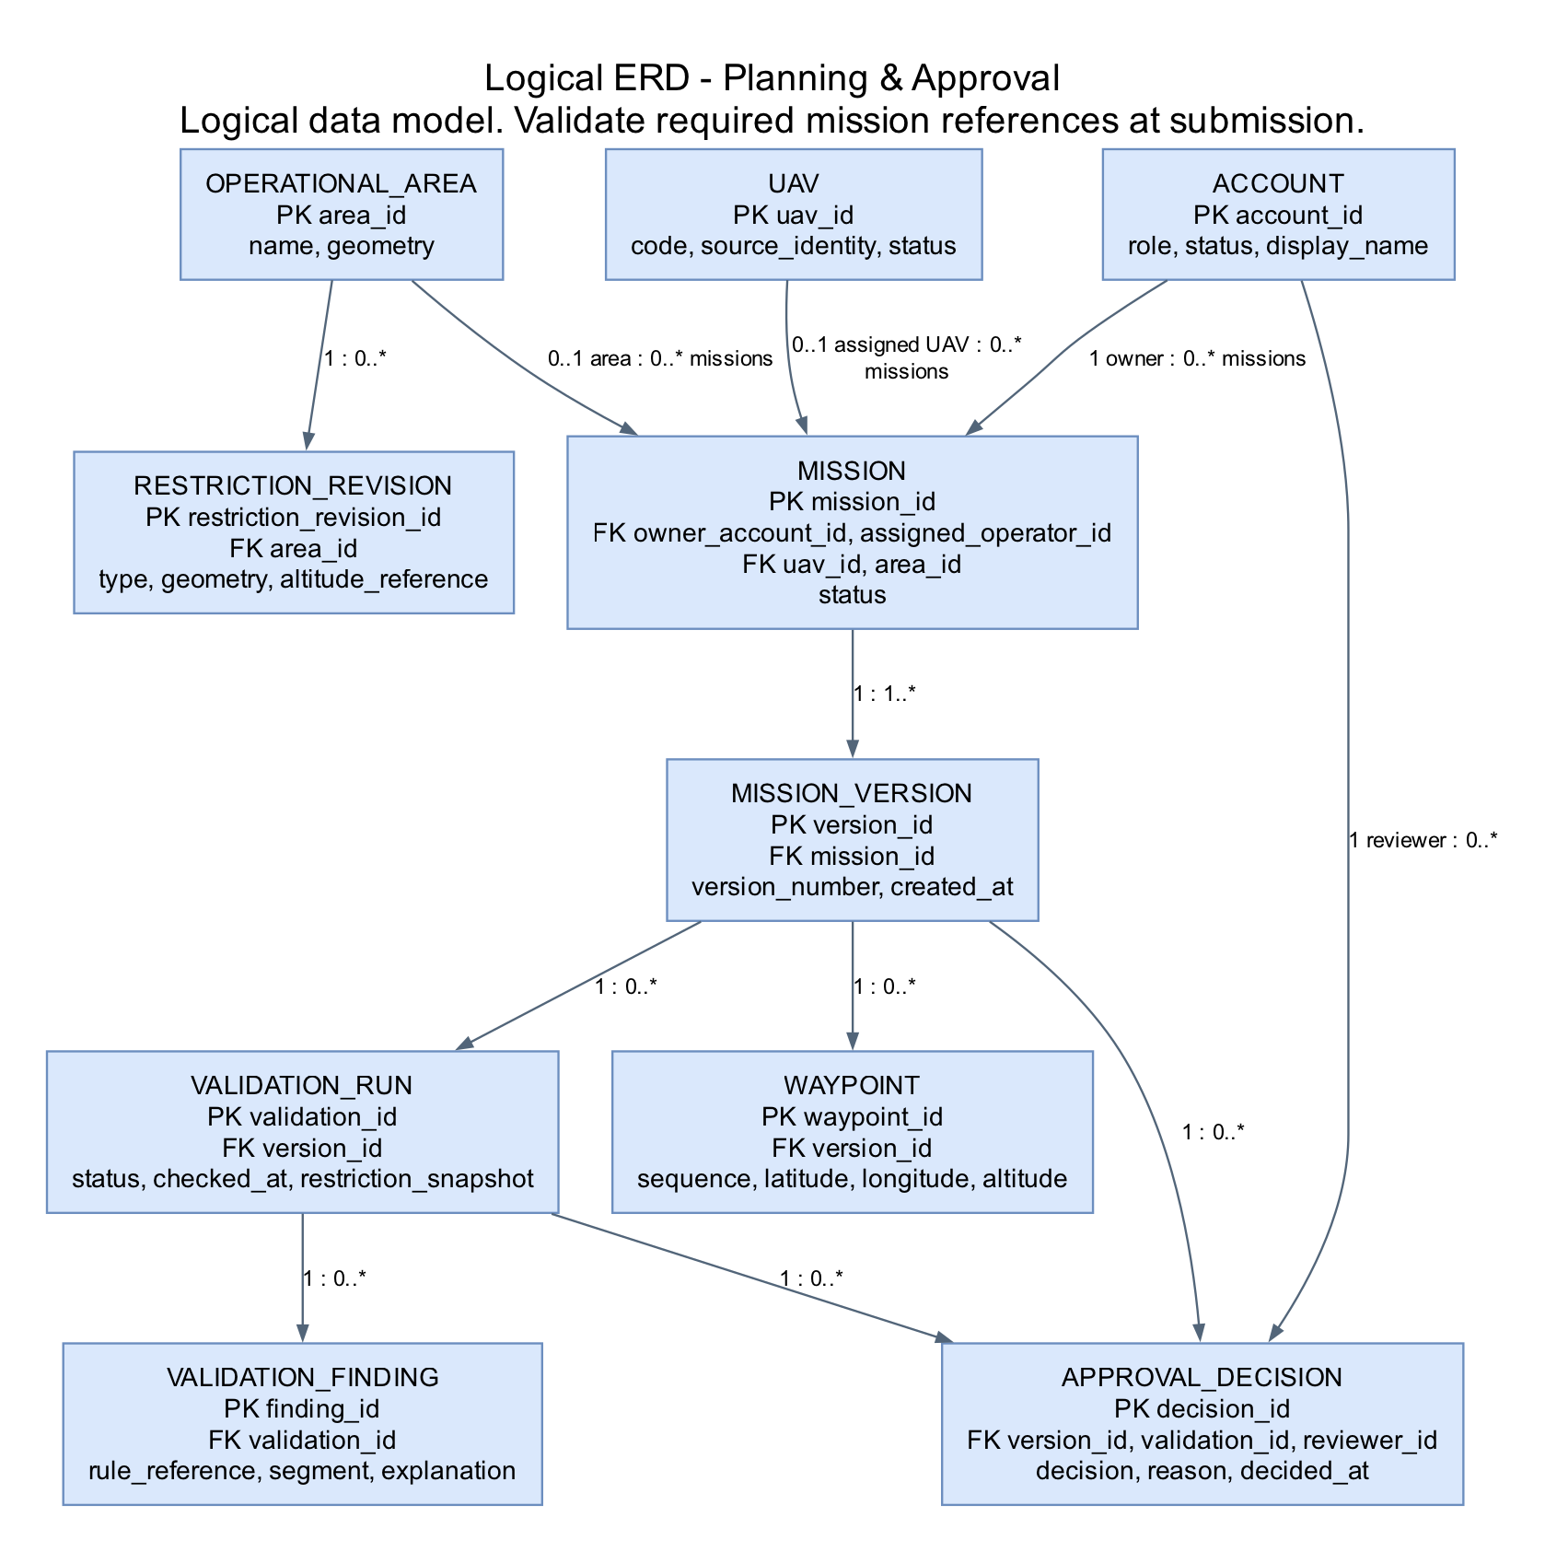
Figure 8. Logical ERD — planning, route versions, validation and decisions.
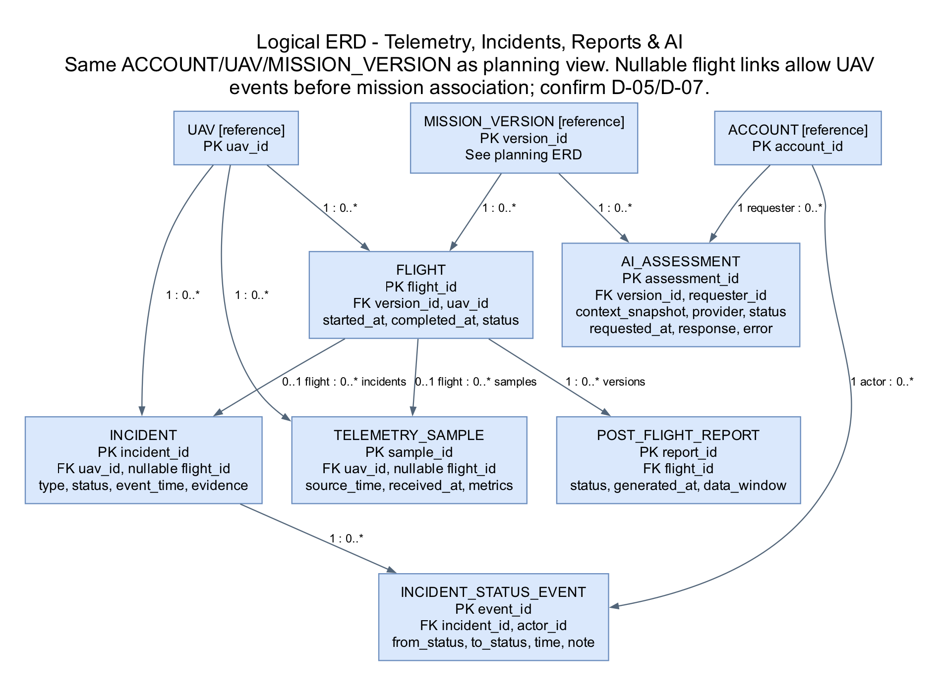
Figure 9. Logical ERD — flight evidence, incidents, post-flight reports and AI assessments.
# | Entity | Description
1 | ACCOUNT | Human identity, role and status; referenced by ownership, decisions and status events.
2 | UAV | Managed vehicle and configured telemetry identity.
3 | OPERATIONAL_AREA | Named operational geometry used by mission planning.
4 | RESTRICTION_REVISION | Configured/versioned spatial or altitude restriction in an area.
5 | MISSION | Logical mission identity, owner, assignments and current lifecycle state.
6 | MISSION_VERSION | Retained plan version referenced by waypoints, validation, approval and assessment.
7 | WAYPOINT | Ordered position/altitude in a mission version; connecting segments derive from order.
8 | VALIDATION_RUN | Version-specific run status/time with the restriction snapshot used.
9 | VALIDATION_FINDING | Violation/incomplete-check evidence, rule and affected waypoint/segment.
10 | APPROVAL_DECISION | Reviewer decision/reason/time for a specific plan and validation.
11 | FLIGHT | An execution record tied to a plan version and UAV; repeat-flight policy pending D-05.
12 | TELEMETRY_SAMPLE | Timestamped normalized measurements; flight association may initially be unknown.
13 | INCIDENT | Detected abnormal event with source evidence and optional flight association.
14 | INCIDENT_STATUS_EVENT | Who acknowledged/resolved an incident, when and why; immutable history.
15 | POST_FLIGHT_REPORT | Generated flight report version/status and covered data window.
16 | AI_ASSESSMENT | Request context snapshot, requester/provider, result status and advisory response/error.

3.1.6 Mainflow Activity Diagrams
These four existing user-edited swimlanes are reused as the baseline business workflows. Internal service lanes describe processing responsibility; they do not add external actors. Proposed incident acknowledgement/resolution and lifecycle details below extend these high-level flows for review.
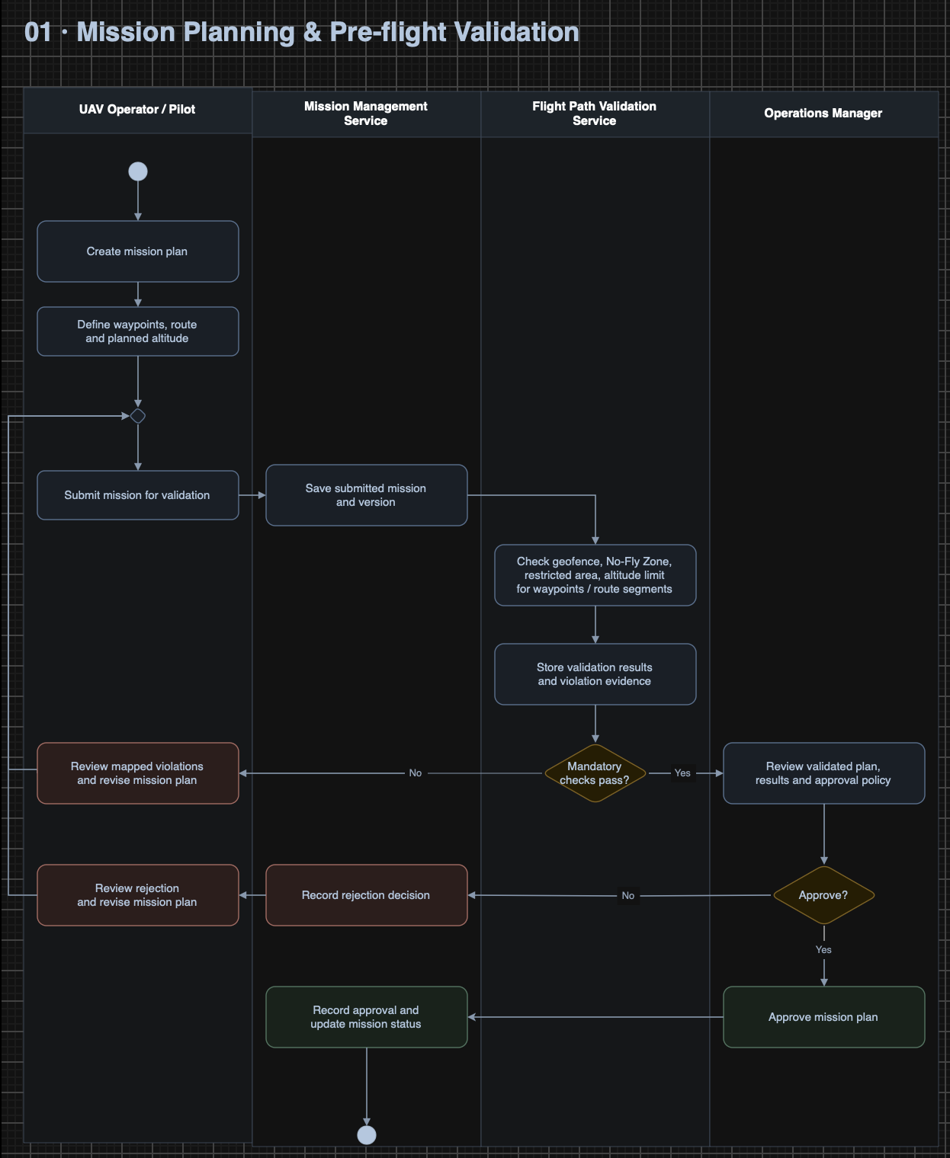
Figure 10. Existing mainflow swimlane — 01. Mission Planning & Pre-flight Validation.
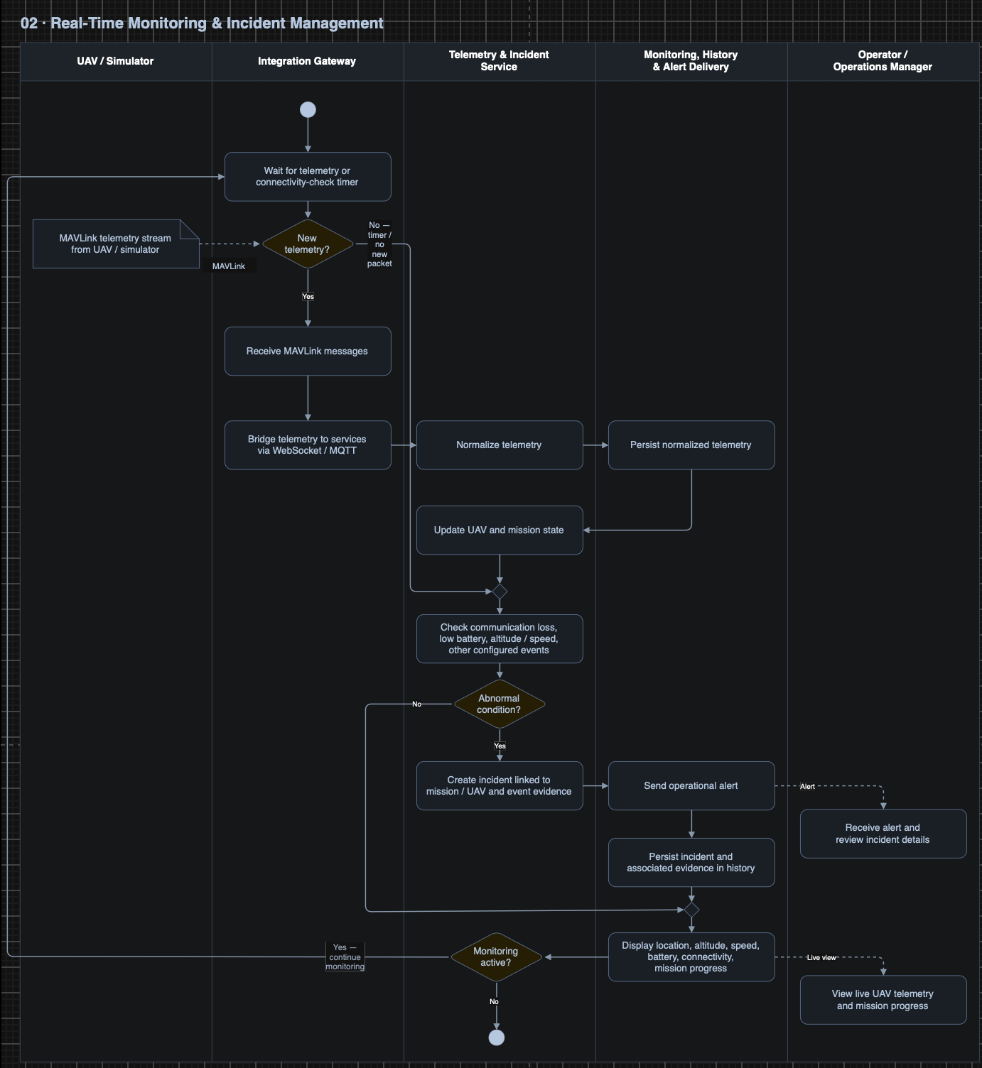
Figure 11. Real-Time Monitoring & Incident Management.
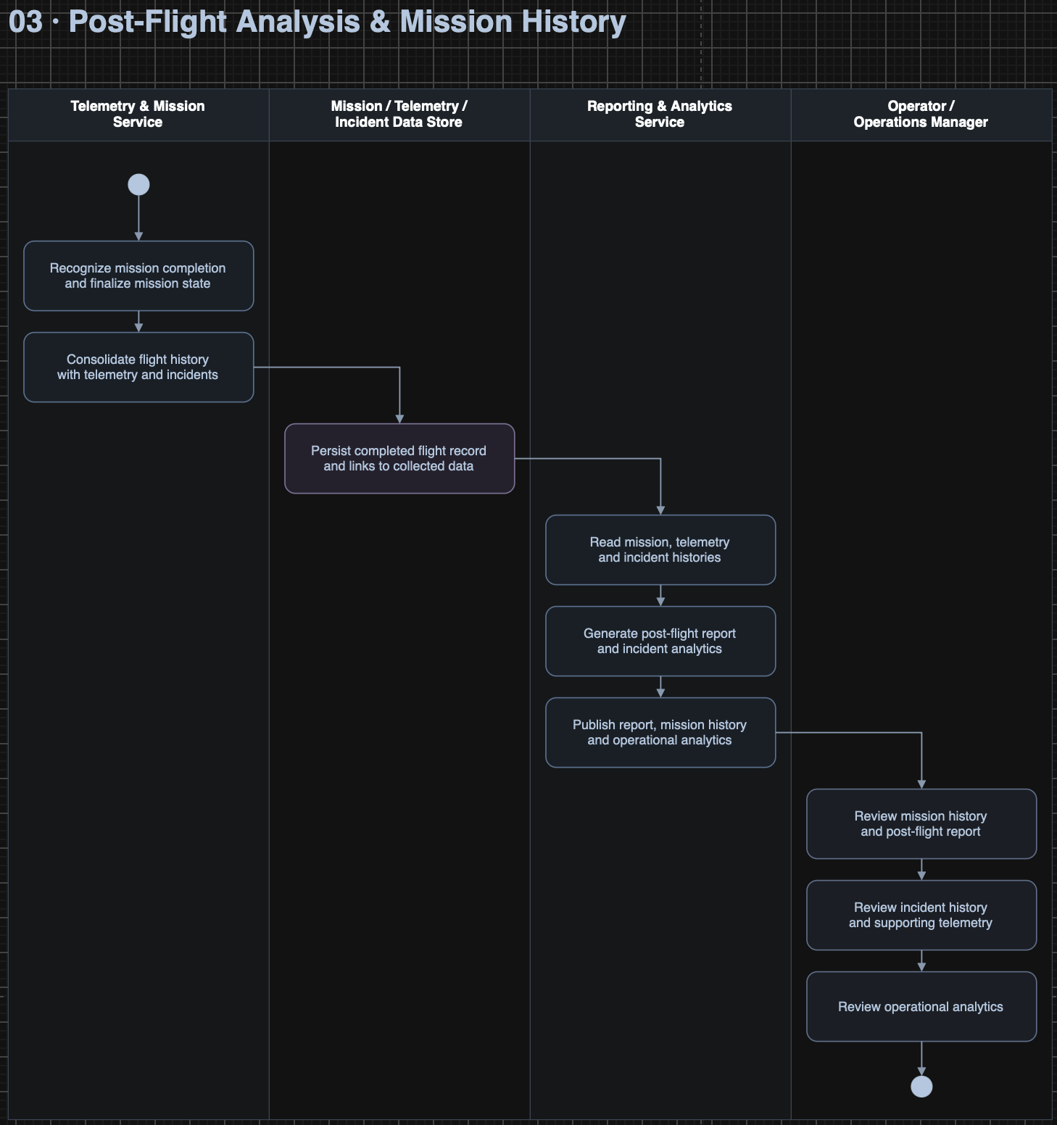
Figure 12. Post-Flight Analysis & Mission History.
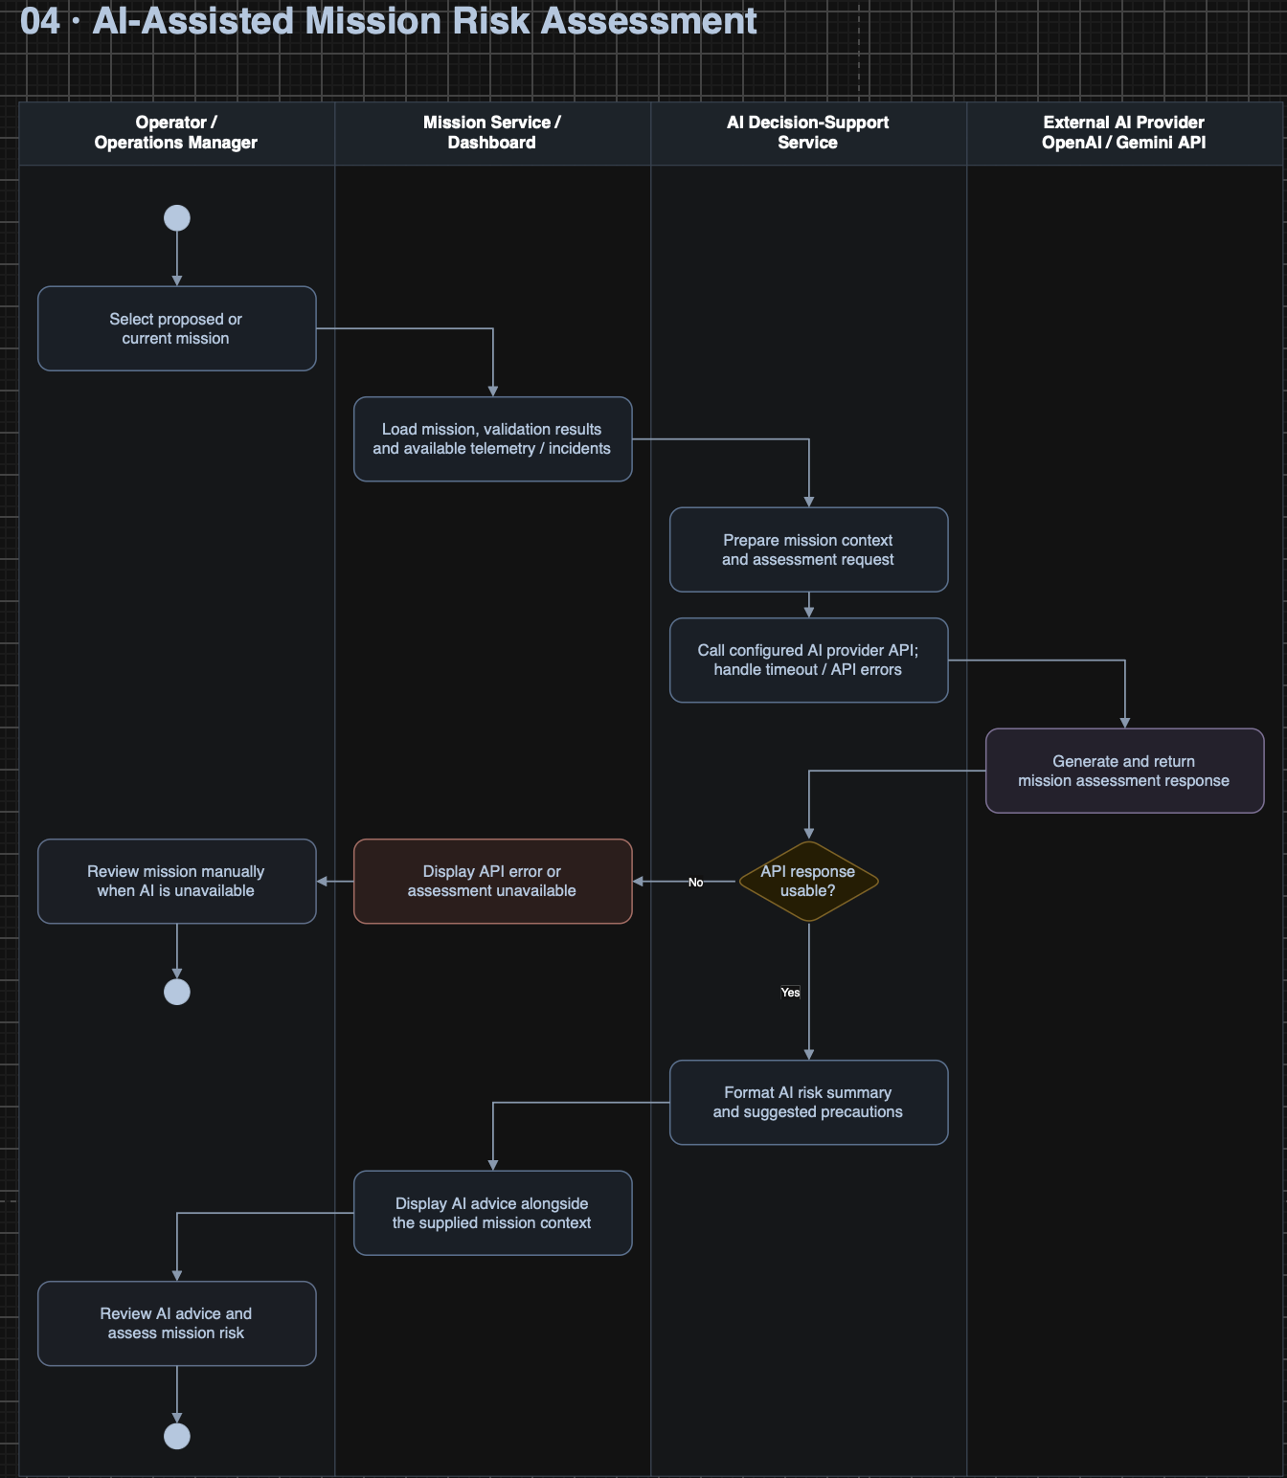
Figure 13. AI-Assisted Mission Risk Assessment.

3.1.7 Lifecycle Diagrams
Both state models are proposed elaborations of the existing workflows. Confirm D-03 and D-06 before using them as an acceptance baseline. Validation runs have independent pass/fail/incomplete outcomes; a failed validation does not advance the mission to Pending Review.
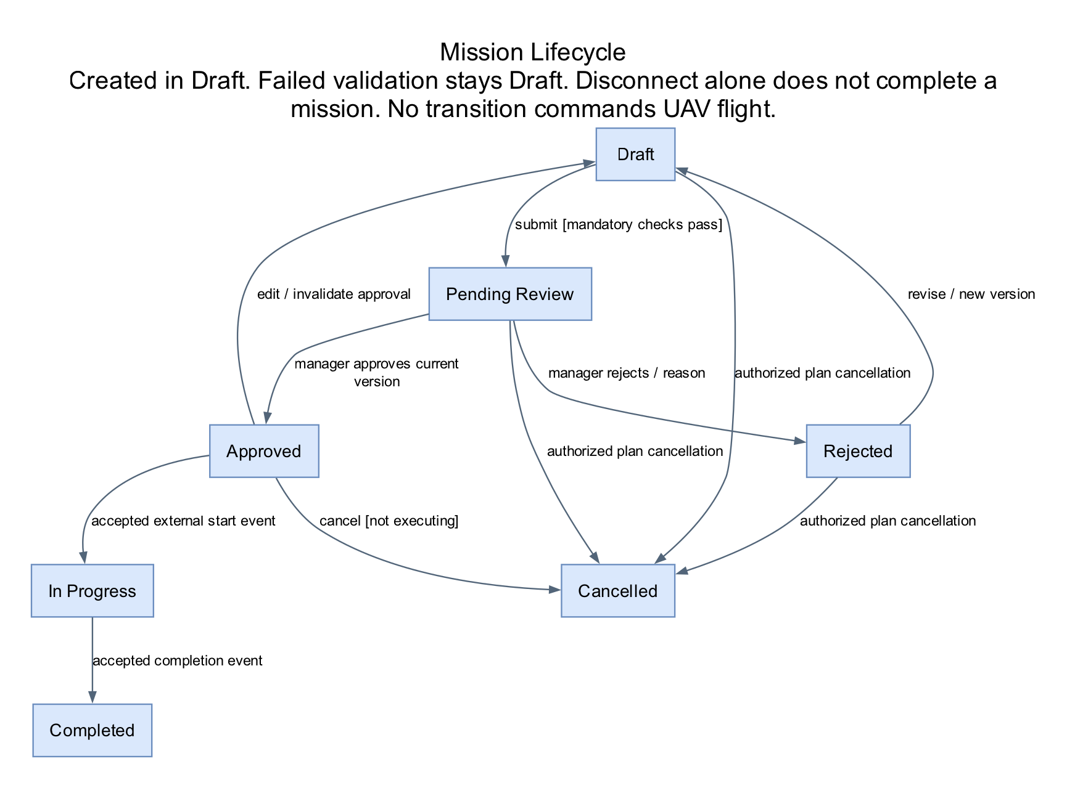
Figure 14. Mission lifecycle (see D-03).
Rejected plans return to Draft when revised. Approved-plan edits create a draft version and invalidate prior approval for that version. Cancellation changes only a planning record; execution events originate outside this application. Handling an unexpected flight for an unapproved plan requires D-05 and must not silently create approval.
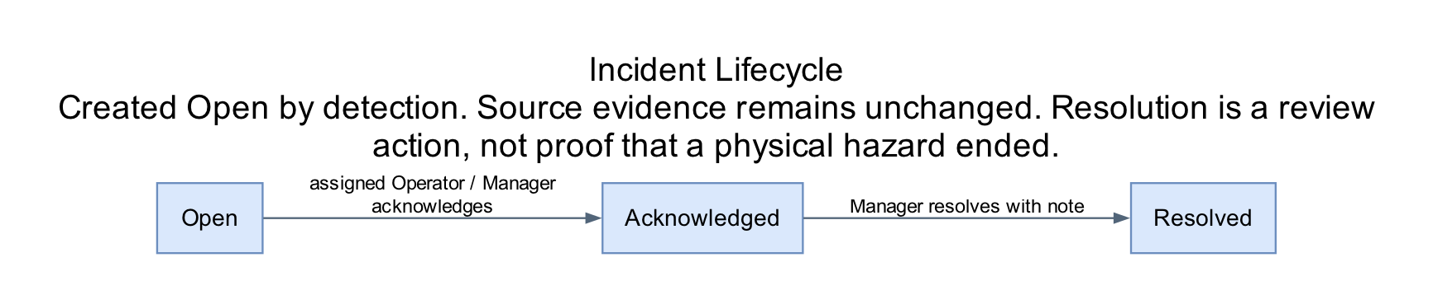
Figure 15. Incident lifecycle (see D-06).

3.2 FE-01 — UAV and Operator Management

3.2.1 Sign in and sign out (UC-01)
Specification | Details
Actors / Interface | Operator; Manager | SCR-01
Trigger | Open the application or select Sign out.
Preconditions | Human actions require an authenticated session and permission for the target record. Background actions require configured source identity and the relevant saved record; details below apply.
Input / Data | Account identifier and password.
FR-01.1 — Normal flow | The system shall support the following behavior: Verify credentials and active account status; create a session; show only permitted navigation. Sign out invalidates the session.
FR-01.2 — Validation / Alternative flow | The system shall enforce the following checks and outcomes: Invalid credentials show MSG-02 without identifying which field is wrong; inactive account or expired session is denied; unauthorized direct URL/API access is rejected.
FR-01.3 — Postcondition | The system shall provide: Authenticated role-scoped session or signed-out state.
Rules / Open decisions | BR-01; CR-01; D-01
Acceptance evidence | Execute the normal scenario and each listed error/denied/stale-data scenario with controlled data; assert the stated outcome and audit/state changes. Requirements trace to UC-01 and FE-01.
Screen layout placeholder — SHOT-01 / SCR-01
APPLICATION SCREENSHOT TO INSERT
SHOT-01 — Sign In
Web navigation: Login page before authentication
Capture: Form and invalid-credential message
No application screenshot supplied. Insert an actual screenshot or clearly labelled approved mockup here.
Ghi chú chèn hình: Chụp trang đăng nhập và một trạng thái nhập sai thông tin.

3.2.2 Manage UAV records (UC-02)
Specification | Details
Actors / Interface | Manager; Operator (view only) | SCR-03
Trigger | Management > UAVs > Add / Edit / Deactivate.
Preconditions | Human actions require an authenticated session and permission for the target record. Background actions require configured source identity and the relevant saved record; details below apply.
Input / Data | Unique UAV code, name, model, operational status and configured telemetry identity.
FR-02.1 — Normal flow | The system shall support the following behavior: List/search UAVs; validate required/unique identifiers; save a UAV record; keep historical mission references when deactivating. Operators can view assigned UAV information.
FR-02.2 — Validation / Alternative flow | The system shall enforce the following checks and outcomes: Duplicate identity or invalid data is rejected; concurrent update requires reload; prohibit deactivation during an active mission under D-02.
FR-02.3 — Postcondition | The system shall provide: Saved UAV record and recorded actor/time of change.
Rules / Open decisions | BR-02; BR-12; D-02
Acceptance evidence | Execute the normal scenario and each listed error/denied/stale-data scenario with controlled data; assert the stated outcome and audit/state changes. Requirements trace to UC-02 and FE-01.
Screen layout placeholder — SHOT-03 / SCR-03
APPLICATION SCREENSHOT TO INSERT
SHOT-03 — UAV Management
Web navigation: Management > UAVs
Capture: List plus Add/Edit UAV form
No application screenshot supplied. Insert an actual screenshot or clearly labelled approved mockup here.
Ghi chú chèn hình: Chụp danh sách UAV và form thêm/sửa UAV bằng tài khoản Manager.

3.2.3 Manage operators and assignments (UC-03)
Specification | Details
Actors / Interface | Manager | SCR-04
Trigger | Management > Operators > Add / Edit / Assign.
Preconditions | Human actions require an authenticated session and permission for the target record. Background actions require configured source identity and the relevant saved record; details below apply.
Input / Data | Operator name, account identifier, status and mission/UAV assignment.
FR-03.1 — Normal flow | The system shall support the following behavior: Create/update operator profiles; enable/disable access; assign an eligible operator to a mission; preserve past assignments. Role provisioning is limited to the proposed manager policy.
FR-03.2 — Validation / Alternative flow | The system shall enforce the following checks and outcomes: Duplicate account or inactive assignee is rejected; prevent removal of the last active manager under D-01; no public self-registration is assumed.
FR-03.3 — Postcondition | The system shall provide: Updated operator/assignment records.
Rules / Open decisions | BR-01; BR-02; D-01; D-02
Acceptance evidence | Execute the normal scenario and each listed error/denied/stale-data scenario with controlled data; assert the stated outcome and audit/state changes. Requirements trace to UC-03 and FE-01.
Screen layout placeholder — SHOT-04 / SCR-04
APPLICATION SCREENSHOT TO INSERT
SHOT-04 — Operator Management
Web navigation: Management > Operators
Capture: Operator list, account status and assignment form
No application screenshot supplied. Insert an actual screenshot or clearly labelled approved mockup here.
Ghi chú chèn hình: Chụp danh sách Operator và form thông tin, trạng thái hoặc phân công bằng Manager.

3.2.4 Configure operational restrictions (UC-04)
Specification | Details
Actors / Interface | Manager | SCR-05
Trigger | Management > Operational Areas & Restrictions.
Preconditions | Human actions require an authenticated session and permission for the target record. Background actions require configured source identity and the relevant saved record; details below apply.
Input / Data | Area name, polygon/coordinates, restriction type, altitude limit and applicable reference/units.
FR-04.1 — Normal flow | The system shall support the following behavior: Create/view/edit configured operational areas, geofences, No-Fly Zones and restricted areas; validate geometry; save a restriction revision for subsequent validation.
FR-04.2 — Validation / Alternative flow | The system shall enforce the following checks and outcomes: Reject malformed or empty geometry; require an agreed altitude reference; warn when edits make an approved plan require revalidation under D-03. Import format is deferred.
FR-04.3 — Postcondition | The system shall provide: Versioned operational restrictions available to validation.
Rules / Open decisions | BR-03; BR-04; D-03; D-04
Acceptance evidence | Execute the normal scenario and each listed error/denied/stale-data scenario with controlled data; assert the stated outcome and audit/state changes. Requirements trace to UC-04 and FE-01.
Screen layout placeholder — SHOT-05 / SCR-05
APPLICATION SCREENSHOT TO INSERT
SHOT-05 — Areas & Restrictions
Web navigation: Management > Operational Areas & Restrictions
Capture: Map, polygon editor, restriction type and altitude fields
No application screenshot supplied. Insert an actual screenshot or clearly labelled approved mockup here.
Ghi chú chèn hình: Chụp bản đồ vùng hoạt động/NFZ, polygon và trường giới hạn độ cao bằng Manager.

3.3 FE-02 — Mission Planning and Management

3.3.1 Create a mission plan (UC-05)
Specification | Details
Actors / Interface | Operator | SCR-07
Trigger | Missions > New Mission.
Preconditions | Human actions require an authenticated session and permission for the target record. Background actions require configured source identity and the relevant saved record; details below apply.
Input / Data | Name, purpose, UAV/operator, operational area and proposed schedule if used.
FR-05.1 — Normal flow | The system shall support the following behavior: Create a Draft mission, assign identifiers, then open the route editor. Save the plan without submission or flight execution.
FR-05.2 — Validation / Alternative flow | The system shall enforce the following checks and outcomes: Required fields missing or inactive assignments cause validation errors; unsaved navigation prompts confirmation.
FR-05.3 — Postcondition | The system shall provide: Draft mission owned by the creator.
Rules / Open decisions | BR-02; BR-05; D-02
Acceptance evidence | Execute the normal scenario and each listed error/denied/stale-data scenario with controlled data; assert the stated outcome and audit/state changes. Requirements trace to UC-05 and FE-02.

Screen layout placeholder — SHOT-07 / SCR-07
APPLICATION SCREENSHOT TO INSERT
SHOT-07 — Mission Editor
Web navigation: Missions > New Mission or Details > Edit
Capture: Metadata, UAV/operator selection, ordered waypoint list and route map
No application screenshot supplied. Insert an actual screenshot or clearly labelled approved mockup here.
Ghi chú chèn hình: Chụp form mission, danh sách waypoint và đường nối trên bản đồ; nên có một lỗi dữ liệu mẫu.

3.3.2 Edit a route and mission version (UC-06)
Specification | Details
Actors / Interface | Operator; Manager (proposed scope) | SCR-07
Trigger | Missions > Mission Details > Edit Plan.
Preconditions | Human actions require an authenticated session and permission for the target record. Background actions require configured source identity and the relevant saved record; details below apply.
Input / Data | Ordered waypoint coordinates and planned altitude; mission metadata.
FR-06.1 — Normal flow | The system shall support the following behavior: Add/move/remove/reorder waypoints and display connecting segments; validate ranges; save changes only in eligible Draft/Rejected states or create a new draft version from an Approved plan under D-03. A Pending Review plan must first leave review through rejection or permitted cancellation; it cannot be edited in place. Manager edit rights follow the same state restrictions.
FR-06.2 — Validation / Alternative flow | The system shall enforce the following checks and outcomes: Invalid coordinates or incomplete route are rejected; stale version edits return conflict; In Progress/Completed records cannot be overwritten; approved plan changes require fresh validation/approval.
FR-06.3 — Postcondition | The system shall provide: Saved version with author/time; earlier reviewed evidence retained.
Rules / Open decisions | BR-04; BR-05; BR-06; D-03; D-04
Acceptance evidence | Execute the normal scenario and each listed error/denied/stale-data scenario with controlled data; assert the stated outcome and audit/state changes. Requirements trace to UC-06 and FE-02.

3.3.3 View or cancel a mission plan (UC-07)
Specification | Details
Actors / Interface | Operator; Manager | SCR-06 / SCR-08
Trigger | Missions > select mission; choose Cancel if permitted.
Preconditions | Human actions require an authenticated session and permission for the target record. Background actions require configured source identity and the relevant saved record; details below apply.
Input / Data | Mission ID, search/filter and cancellation reason.
FR-07.1 — Normal flow | The system shall support the following behavior: Display current/versioned plan, validation and decisions. If cancellation is permitted, confirm the action, preserve history and mark the plan Cancelled.
FR-07.2 — Validation / Alternative flow | The system shall enforce the following checks and outcomes: Cancel is limited to non-executing plans under D-03. An In Progress mission cannot be stopped by this action; flight control remains external.
FR-07.3 — Postcondition | The system shall provide: Mission details shown or planning record cancelled with audit evidence.
Rules / Open decisions | BR-01; BR-05; BR-06; D-03
Acceptance evidence | Execute the normal scenario and each listed error/denied/stale-data scenario with controlled data; assert the stated outcome and audit/state changes. Requirements trace to UC-07 and FE-02.
Screen layout placeholder — SHOT-06 / SCR-06
APPLICATION SCREENSHOT TO INSERT
SHOT-06 — Mission List
Web navigation: Missions
Capture: Search/filter, status column and New Mission action
No application screenshot supplied. Insert an actual screenshot or clearly labelled approved mockup here.
Ghi chú chèn hình: Chụp danh sách mission có bộ lọc và nhiều trạng thái.
Screen layout placeholder — SHOT-08 / SCR-08
APPLICATION SCREENSHOT TO INSERT
SHOT-08 — Mission Details & Validation
Web navigation: Missions > select mission
Capture: Overview, versions/decisions and validation map with failing segments
No application screenshot supplied. Insert an actual screenshot or clearly labelled approved mockup here.
Ghi chú chèn hình: Chụp các tab thông tin, phiên bản/quyết định và Validation; cần một ảnh có đoạn đường vi phạm được tô màu.

3.4 FE-03 — Mission Approval Workflow

3.4.1 Submit a mission for validation (UC-08)
Specification | Details
Actors / Interface | Operator | SCR-08
Trigger | Mission Details > Submit.
Preconditions | Human actions require an authenticated session and permission for the target record. Background actions require configured source identity and the relevant saved record; details below apply.
Input / Data | Saved mission version with route and required assignment data.
FR-08.1 — Normal flow | The system shall support the following behavior: Check user/state/version; capture a submitted version; invoke UC-11; persist validation evidence. A passing result places the version in Pending Review; failed mandatory checks return it for revision.
FR-08.2 — Validation / Alternative flow | The system shall enforce the following checks and outcomes: Missing data prevents submission; validation unavailable is not treated as pass; repeated submission of the same version does not create duplicate active requests.
FR-08.3 — Postcondition | The system shall provide: Validated version pending manager review or actionable validation failure.
Rules / Open decisions | BR-03; BR-05; BR-06
Acceptance evidence | Execute the normal scenario and each listed error/denied/stale-data scenario with controlled data; assert the stated outcome and audit/state changes. Requirements trace to UC-08 and FE-03.

3.4.2 Approve or reject a mission (UC-09)
Specification | Details
Actors / Interface | Manager | SCR-09
Trigger | Approvals > select pending mission.
Preconditions | Human actions require an authenticated session and permission for the target record. Background actions require configured source identity and the relevant saved record; details below apply.
Input / Data | Submitted version, validation evidence, decision and rejection reason.
FR-09.1 — Normal flow | The system shall support the following behavior: Review current version and mandatory validation results; approve a passing version or reject with a reason; record decision, reviewer and timestamp; notify the operator in the application.
FR-09.2 — Validation / Alternative flow | The system shall enforce the following checks and outcomes: Stale version/changed restrictions require revalidation; invalid or missing validation blocks approval; duplicate/conflicting decisions return current state. Self-approval policy is D-03.
FR-09.3 — Postcondition | The system shall provide: Immutable decision linked to the reviewed version; Approved or Rejected state.
Rules / Open decisions | BR-03; BR-05; BR-06; D-03
Acceptance evidence | Execute the normal scenario and each listed error/denied/stale-data scenario with controlled data; assert the stated outcome and audit/state changes. Requirements trace to UC-09 and FE-03.
Screen layout placeholder — SHOT-09 / SCR-09
APPLICATION SCREENSHOT TO INSERT
SHOT-09 — Approval Review
Web navigation: Approvals > pending mission
Capture: Submitted version, evidence, Approve/Reject and rejection-reason dialog
No application screenshot supplied. Insert an actual screenshot or clearly labelled approved mockup here.
Ghi chú chèn hình: Chụp màn hình Manager duyệt mission, bằng chứng validation và hộp thoại nhập lý do Reject.

3.4.3 Review approval history (UC-10)
Specification | Details
Actors / Interface | Operator; Manager | SCR-08
Trigger | Mission Details > Versions & Decisions.
Preconditions | Human actions require an authenticated session and permission for the target record. Background actions require configured source identity and the relevant saved record; details below apply.
Input / Data | Mission ID and selected version.
FR-10.1 — Normal flow | The system shall support the following behavior: Show submission, validation, decision, reviewer/time and rejection reasons in order; scope operator access to permitted missions.
FR-10.2 — Validation / Alternative flow | The system shall enforce the following checks and outcomes: No prior decision displays an empty state; inaccessible version is denied.
FR-10.3 — Postcondition | The system shall provide: Traceable approval history.
Rules / Open decisions | BR-01; BR-06
Acceptance evidence | Execute the normal scenario and each listed error/denied/stale-data scenario with controlled data; assert the stated outcome and audit/state changes. Requirements trace to UC-10 and FE-03.

3.5 FE-04 — Geofence and Flight Path Validation

3.5.1 Validate waypoints and route segments (UC-11)
Specification | Details
Actors / Interface | Operator (via submission) | SCR-08 / background
Trigger | Submission or an authorized revalidation request.
Preconditions | Human actions require an authenticated session and permission for the target record. Background actions require configured source identity and the relevant saved record; details below apply.
Input / Data | Saved route/version and current configured restrictions.
FR-11.1 — Normal flow | The system shall support the following behavior: Check all waypoints and connecting segments against geofence, No-Fly Zone, restricted area and altitude constraints; persist pass/fail with violating segment/waypoint and rule evidence.
FR-11.2 — Validation / Alternative flow | The system shall enforce the following checks and outcomes: Unavailable restriction data or invalid geometry yields an explicit incomplete/error result, never a silent pass; boundary/altitude semantics require D-04.
FR-11.3 — Postcondition | The system shall provide: Version-linked validation result and map evidence.
Rules / Open decisions | BR-03; BR-04; D-04
Acceptance evidence | Execute the normal scenario and each listed error/denied/stale-data scenario with controlled data; assert the stated outcome and audit/state changes. Requirements trace to UC-11 and FE-04.

3.5.2 Review mapped validation results (UC-12)
Specification | Details
Actors / Interface | Operator; Manager | SCR-08
Trigger | Mission Details > Validation.
Preconditions | Human actions require an authenticated session and permission for the target record. Background actions require configured source identity and the relevant saved record; details below apply.
Input / Data | Validation run ID and related mission version.
FR-12.1 — Normal flow | The system shall support the following behavior: Highlight failed waypoints/segments on the map; list violated configured rule and explanation; show pass/fail/incomplete and validation timestamp.
FR-12.2 — Validation / Alternative flow | The system shall enforce the following checks and outcomes: Map provider failure leaves a textual violation list accessible; an old run is labelled outdated.
FR-12.3 — Postcondition | The system shall provide: User can locate violations and decide whether to edit/resubmit.
Rules / Open decisions | BR-03; BR-06
Acceptance evidence | Execute the normal scenario and each listed error/denied/stale-data scenario with controlled data; assert the stated outcome and audit/state changes. Requirements trace to UC-12 and FE-04.
Input validation detail: latitude must be within [-90, 90] degrees and longitude within [-180, 180] degrees; waypoint ordering must be unambiguous. The approved coordinate/altitude reference, valid polygon rules and treatment of boundary intersections remain D-04.

3.6 FE-05 — MAVLink Telemetry Integration

3.6.1 Provide and ingest telemetry (UC-13)
Specification | Details
Actors / Interface | UAV/Autopilot or Simulator | Non-screen
Trigger | Configured source sends MAVLink data to the integration gateway.
Preconditions | Human actions require an authenticated session and permission for the target record. Background actions require configured source identity and the relevant saved record; details below apply.
Input / Data | Source identity, message timestamp and supported location/altitude/speed/battery/state fields.
FR-13.1 — Normal flow | The system shall support the following behavior: Accept a configured source; normalize units/fields; persist timestamps and validity; associate data with the correct UAV and, when known, flight; update latest valid state and publish an update.
FR-13.2 — Validation / Alternative flow | The system shall enforce the following checks and outcomes: Malformed/unsupported packets are rejected/logged; missing values stay unavailable, not zero; out-of-order samples must not replace newer live state; association/retry/deduplication policy is D-05.
FR-13.3 — Postcondition | The system shall provide: Stored telemetry and updated UAV/mission projection without flight-control commands.
Rules / Open decisions | BR-07; BR-08; D-05
Acceptance evidence | Execute the normal scenario and each listed error/denied/stale-data scenario with controlled data; assert the stated outcome and audit/state changes. Requirements trace to UC-13 and FE-05.
No application screenshot is required for the raw gateway. Verify ingestion and mapping through integration-test evidence and the visible Live Monitoring screen (SHOT-10). Do not insert API keys, provider tokens or connection secrets into this report.

3.7 FE-06 — Real-Time Mission Monitoring

3.7.1 Monitor an active mission (UC-14)
Specification | Details
Actors / Interface | Operator; Manager | SCR-10
Trigger | Live Monitoring > select active mission/UAV.
Preconditions | Human actions require an authenticated session and permission for the target record. Background actions require configured source identity and the relevant saved record; details below apply.
Input / Data | Authorized mission/UAV selection and live telemetry projection.
FR-14.1 — Normal flow | The system shall support the following behavior: Display location, altitude, speed, battery, connectivity, sample freshness and mission progress; refresh as accepted samples arrive; retain links to relevant incidents.
FR-14.2 — Validation / Alternative flow | The system shall enforce the following checks and outcomes: No packet/stale stream shows last-known values with timestamp and stale/offline status; never imply stale values are live; reconnect refreshes the latest valid state.
FR-14.3 — Postcondition | The system shall provide: Real-time operational view with explicit freshness.
Rules / Open decisions | BR-07; BR-08; D-05
Acceptance evidence | Execute the normal scenario and each listed error/denied/stale-data scenario with controlled data; assert the stated outcome and audit/state changes. Requirements trace to UC-14 and FE-06.
Screen layout placeholder — SHOT-10 / SCR-10
APPLICATION SCREENSHOT TO INSERT
SHOT-10 — Live Monitoring
Web navigation: Live Monitoring > select mission
Capture: Live map, six telemetry indicators, timestamp/freshness, progress and alerts
No application screenshot supplied. Insert an actual screenshot or clearly labelled approved mockup here.
Ghi chú chèn hình: Chụp màn hình theo dõi có location, altitude, speed, battery, connectivity, progress; thêm ảnh mất kết nối/stale.

3.8 FE-07 — Operational Alert and Incident Detection

3.8.1 Detect incidents and deliver alerts (UC-15)
Specification | Details
Actors / Interface | UAV/Simulator (data source); Operator; Manager | SCR-10 / SCR-11 / background
Trigger | Accepted telemetry or connectivity-check timer.
Preconditions | Human actions require an authenticated session and permission for the target record. Background actions require configured source identity and the relevant saved record; details below apply.
Input / Data | Telemetry, last-seen time and configured abnormal-event rules.
FR-15.1 — Normal flow | The system shall support the following behavior: Evaluate communication loss, low battery and abnormal altitude/speed; create an incident linked to UAV/mission and evidence; persist it and deliver an in-app alert to permitted users. Run communication-loss checks even with no new packet.
FR-15.2 — Validation / Alternative flow | The system shall enforce the following checks and outcomes: Missing required metric suppresses only that metric rule with diagnostic evidence; persistent abnormality must not flood duplicates under D-06; reconnect/notification failure preserves incident history.
FR-15.3 — Postcondition | The system shall provide: Persisted incident and available in-app alert; no autonomous control action.
Rules / Open decisions | BR-08; BR-09; D-06
Acceptance evidence | Execute the normal scenario and each listed error/denied/stale-data scenario with controlled data; assert the stated outcome and audit/state changes. Requirements trace to UC-15 and FE-07.

Screen layout placeholder — SHOT-11 / SCR-11
APPLICATION SCREENSHOT TO INSERT
SHOT-11 — Incident List
Web navigation: Incidents
Capture: Filters, type/severity/status and affected mission
No application screenshot supplied. Insert an actual screenshot or clearly labelled approved mockup here.
Ghi chú chèn hình: Chụp danh sách incident, bộ lọc loại/trạng thái và liên kết mission.
Detection thresholds are configuration requirements awaiting D-06, not aviation regulations or hard-coded values asserted by this SRS. The same persistent abnormal event should not generate unlimited new incidents; define its identity/window during review.

3.9 FE-08 — Incident Management and Post-Flight Analysis

3.9.1 Review and manage an incident (UC-16)
Specification | Details
Actors / Interface | Operator; Manager | SCR-11 / SCR-12
Trigger | Incidents > select incident; acknowledge or resolve if permitted.
Preconditions | Human actions require an authenticated session and permission for the target record. Background actions require configured source identity and the relevant saved record; details below apply.
Input / Data | Incident ID, linked evidence and acknowledgement/resolution note.
FR-16.1 — Normal flow | The system shall support the following behavior: View time, type, affected mission/UAV and telemetry evidence. Proposed workflow allows assigned operator/manager acknowledgement and manager resolution, with actor/time and notes retained.
FR-16.2 — Validation / Alternative flow | The system shall enforce the following checks and outcomes: Unauthorized transition rejected; concurrent update requires reload; absent evidence is labelled unavailable. Acknowledgement does not alter measured telemetry or suppress unrelated alerts.
FR-16.3 — Postcondition | The system shall provide: Reviewed incident with append-only status history.
Rules / Open decisions | BR-01; BR-09; BR-12; D-06
Acceptance evidence | Execute the normal scenario and each listed error/denied/stale-data scenario with controlled data; assert the stated outcome and audit/state changes. Requirements trace to UC-16 and FE-08.
Screen layout placeholder — SHOT-12 / SCR-12
APPLICATION SCREENSHOT TO INSERT
SHOT-12 — Incident Details
Web navigation: Incidents > select incident
Capture: Event evidence, linked telemetry, history and acknowledgement/resolution controls
No application screenshot supplied. Insert an actual screenshot or clearly labelled approved mockup here.
Ghi chú chèn hình: Chụp chi tiết incident gồm dữ liệu thời điểm xảy ra, lịch sử và nút acknowledge/resolve theo vai trò.

3.9.2 Finalize a flight and generate a post-flight report (UC-17)
Specification | Details
Actors / Interface | UAV/Autopilot or Simulator (completion source) | SCR-14 / background
Trigger | Configured completion event accepted for a known mission/flight.
Preconditions | Human actions require an authenticated session and permission for the target record. Background actions require configured source identity and the relevant saved record; details below apply.
Input / Data | Flight identity, completion state/time, stored telemetry and incidents.
FR-17.1 — Normal flow | The system shall support the following behavior: Recognize completion; finalize the flight record; consolidate telemetry/incident links; generate report summary and analytics; publish the report for authorized review.
FR-17.2 — Validation / Alternative flow | The system shall enforce the following checks and outcomes: Connection loss alone is not completion; ambiguous completion remains unresolved; report-generation error exposes Failed/Retry status and preserves flight data; late-data policy is D-05.
FR-17.3 — Postcondition | The system shall provide: Completed flight history and available or explicitly failed report.
Rules / Open decisions | BR-07; BR-10; D-05
Acceptance evidence | Execute the normal scenario and each listed error/denied/stale-data scenario with controlled data; assert the stated outcome and audit/state changes. Requirements trace to UC-17 and FE-08.
Screen layout placeholder — SHOT-14 / SCR-14
APPLICATION SCREENSHOT TO INSERT
SHOT-14 — Flight Details & Post-Flight Report
Web navigation: Mission History > select flight
Capture: Recorded route, telemetry summary, incidents and report status/content
No application screenshot supplied. Insert an actual screenshot or clearly labelled approved mockup here.
Ghi chú chèn hình: Chụp kết quả sau chuyến bay: đường bay thực tế, telemetry, incidents và nội dung/status của báo cáo.

3.9.3 Review mission history and post-flight results (UC-18)
Specification | Details
Actors / Interface | Operator; Manager | SCR-13 / SCR-14
Trigger | Mission History > select flight > Report / Incidents.
Preconditions | Human actions require an authenticated session and permission for the target record. Background actions require configured source identity and the relevant saved record; details below apply.
Input / Data | Date/status/UAV filters and flight ID.
FR-18.1 — Normal flow | The system shall support the following behavior: List permitted histories; show planned-versus-recorded route where data exists, duration/telemetry summaries, incidents and post-flight report; link incident details.
FR-18.2 — Validation / Alternative flow | The system shall enforce the following checks and outcomes: No records show an empty state; incomplete telemetry is labelled; pending/failed report shows status and authorized retry under D-07. Export formats are not baselined.
FR-18.3 — Postcondition | The system shall provide: User reviews recorded flight evidence and report.
Rules / Open decisions | BR-01; BR-10; D-07
Acceptance evidence | Execute the normal scenario and each listed error/denied/stale-data scenario with controlled data; assert the stated outcome and audit/state changes. Requirements trace to UC-18 and FE-08.
Screen layout placeholder — SHOT-13 / SCR-13
APPLICATION SCREENSHOT TO INSERT
SHOT-13 — Mission History
Web navigation: Mission History
Capture: Completed flight list with date/UAV/status filters
No application screenshot supplied. Insert an actual screenshot or clearly labelled approved mockup here.
Ghi chú chèn hình: Chụp danh sách flight history có lọc ngày/UAV và liên kết chi tiết.

3.10 FE-09 — AI-Assisted Mission Decision Support

3.10.1 Request an AI-assisted risk assessment (UC-19)
Specification | Details
Actors / Interface | Operator; Manager | SCR-15
Trigger | Mission Details or Live Monitoring > AI Assessment > Generate.
Preconditions | Human actions require an authenticated session and permission for the target record. Background actions require configured source identity and the relevant saved record; details below apply.
Input / Data | Selected proposed/current mission version, validation results and available telemetry/incidents.
FR-19.1 — Normal flow | The system shall support the following behavior: Authorize access; capture relevant source context and missing-data indicators; send a bounded request through the configured OpenAI or Gemini backend adapter; validate usable response; store request status and advisory result linked to context.
FR-19.2 — Validation / Alternative flow | The system shall enforce the following checks and outcomes: No permission/missing essential mission data blocks request; timeout, rate limit, invalid response or provider error shows MSG-11 and allows manual review; secrets never reach the browser.
FR-19.3 — Postcondition | The system shall provide: Available assessment or explicit failed status; no change to mission approval.
Rules / Open decisions | BR-11; BR-12; D-08
Acceptance evidence | Execute the normal scenario and each listed error/denied/stale-data scenario with controlled data; assert the stated outcome and audit/state changes. Requirements trace to UC-19 and FE-09.
Screen layout placeholder — SHOT-15 / SCR-15
APPLICATION SCREENSHOT TO INSERT
SHOT-15 — AI Assessment
Web navigation: Mission Details or Live Monitoring > AI Assessment
Capture: Mission context, Generate/Retry, summary, risks, precautions and unavailable state
No application screenshot supplied. Insert an actual screenshot or clearly labelled approved mockup here.
Ghi chú chèn hình: Chụp context đầu vào và kết quả AI (summary/risks/precautions); thêm ảnh timeout/lỗi có lựa chọn review thủ công.

3.10.2 Review AI advice and supplied context (UC-20)
Specification | Details
Actors / Interface | Operator; Manager | SCR-15
Trigger | Open a completed assessment.
Preconditions | Human actions require an authenticated session and permission for the target record. Background actions require configured source identity and the relevant saved record; details below apply.
Input / Data | Assessment ID, source version/time and provider result.
FR-20.1 — Normal flow | The system shall support the following behavior: Display mission summary, potential risks, suggested precautions and supplied context; clearly label AI-generated advisory content. Both roles may request a new assessment; editable mission context follows UC-06 restrictions.
FR-20.2 — Validation / Alternative flow | The system shall enforce the following checks and outcomes: Changed mission/context marks the result outdated; absent data is shown; users cannot overwrite stored provider output and present it as the original result. No model confidence is invented.
FR-20.3 — Postcondition | The system shall provide: Human-reviewed advisory evidence, with manual mission review still available.
Rules / Open decisions | BR-06; BR-11; D-08
Acceptance evidence | Execute the normal scenario and each listed error/denied/stale-data scenario with controlled data; assert the stated outcome and audit/state changes. Requirements trace to UC-20 and FE-09.

3.11 FE-10 — Mission and Operational Dashboard

3.11.1 View an operational dashboard (UC-21)
Specification | Details
Actors / Interface | Operator; Manager | SCR-02
Trigger | Sign in > Dashboard.
Preconditions | Human actions require an authenticated session and permission for the target record. Background actions require configured source identity and the relevant saved record; details below apply.
Input / Data | Authorized scope and date/status/UAV filters.
FR-21.1 — Normal flow | The system shall support the following behavior: Show mission counts/status, active UAV summaries, recent incidents and shortcuts to validation, monitoring, history and AI assessment; drill down to authorized records. Both roles can change view filters.
FR-21.2 — Validation / Alternative flow | The system shall enforce the following checks and outcomes: No data or partial service failure displays scoped empty/unavailable states; never expose inaccessible counts/details. Dashboard metrics do not directly edit mission evidence.
FR-21.3 — Postcondition | The system shall provide: Role-scoped operational overview.
Rules / Open decisions | BR-01; BR-07; D-09
Acceptance evidence | Execute the normal scenario and each listed error/denied/stale-data scenario with controlled data; assert the stated outcome and audit/state changes. Requirements trace to UC-21 and FE-10.
Screen layout placeholder — SHOT-02 / SCR-02
APPLICATION SCREENSHOT TO INSERT
SHOT-02 — Operational Dashboard
Web navigation: Dashboard
Capture: Summary cards, active missions, recent alerts and navigation
No application screenshot supplied. Insert an actual screenshot or clearly labelled approved mockup here.
Ghi chú chèn hình: Chụp trang tổng quan sau đăng nhập: thẻ số liệu, mission đang chạy và cảnh báo gần đây.

3.11.2 Review operational analytics (UC-22)
Specification | Details
Actors / Interface | Operator; Manager | SCR-16
Trigger | Dashboard > Analytics.
Preconditions | Human actions require an authenticated session and permission for the target record. Background actions require configured source identity and the relevant saved record; details below apply.
Input / Data | Permitted date range, UAV/mission filters and recorded histories/incidents.
FR-22.1 — Normal flow | The system shall support the following behavior: Display defined mission completion/incident summaries and trends; disclose filters, data window and missing-data caveats; link to supporting histories.
FR-22.2 — Validation / Alternative flow | The system shall enforce the following checks and outcomes: Invalid date range is rejected; no data is not displayed as zero-risk; exact metric formulas and export capability require D-09.
FR-22.3 — Postcondition | The system shall provide: Explainable aggregate view backed by recorded data.
Rules / Open decisions | BR-01; BR-10; D-09
Acceptance evidence | Execute the normal scenario and each listed error/denied/stale-data scenario with controlled data; assert the stated outcome and audit/state changes. Requirements trace to UC-22 and FE-10.
Screen layout placeholder — SHOT-16 / SCR-16
APPLICATION SCREENSHOT TO INSERT
SHOT-16 — Operational Analytics
Web navigation: Dashboard > Analytics
Capture: Date/UAV filters, defined metrics/charts and links to histories
No application screenshot supplied. Insert an actual screenshot or clearly labelled approved mockup here.
Ghi chú chèn hình: Chụp analytics với bộ lọc và biểu đồ; số liệu phải khớp dữ liệu lịch sử mẫu.

4. Non-Functional Requirements

4.1 External Interfaces
ID | Interface | Required behavior / Contract boundary
IF-01 | Human Web interface | Provide the proposed screens with role-scoped navigation, explicit validation/status/error feedback and labelled data units/time. A missing map must not hide the textual validation evidence. Exact UI design is pending screenshots.
IF-02 | Operator mobile client | Shared authorization and data semantics apply. Confirm the exact mobile function subset, device support and offline behavior under D-09; this specification does not assert Web/mobile feature parity.
IF-03 | UAV/autopilot or Simulator -> gateway | Receive supported MAVLink telemetry and configured state signals; identify the source, reject malformed data and preserve time/validity. Message subset, identity mapping and completion event are D-05.
IF-04 | Gateway -> platform -> live clients | Use the selected WebSocket or MQTT integration path; normalize/persist and publish authorized state updates. Ordering, deduplication, reconnect and sampling contracts are finalized in SDD/D-05.
IF-05 | Backend -> external AI provider | Call one configured OpenAI or Gemini API with permitted bounded context and server-held credentials; validate usable response, expose failure state and preserve manual review. Provider/model/schema/limits are D-08.
IF-06 | Map/background data | Display route/restriction geometry against a selected map source; provider/licensing/import contract remains a design decision. Configured restrictions are the validation authority within this product.
IF-07 | Persistent storage | Retain versioned plans, decisions and linked flight/incident/report/assessment evidence. Final schema, backup schedule and retention are D-07/D-10.

4.2 Quality Attributes
The following numeric targets are proposed acceptance candidates (D-10), not established commitments from Report 1. Confirm them against the prototype, team capacity and deployment environment before baselining. Test profile P-01 proposes 5 simulated UAVs at 1 normalized sample/second each, 10 concurrent Web sessions, 100 stored flights with 10,000 samples each, and up to 50 waypoints checked against 20 configured polygons of at most 100 vertices each, on an agreed test deployment with external API latency measured separately.

4.2.1 Usability
ID | Requirement | Verification
NFR-U01 | After at most 30 minutes of onboarding, at least 4 of 5 representative testers shall create, validate and submit a prepared 5-waypoint mission within 5 minutes without assistance. | Timed task study; proposed D-10.
NFR-U02 | All required-field errors, stale-data states and permission-denied responses shall be understandable without consulting server logs. Core forms shall be usable with keyboard focus and text labels. | Screen walkthrough and keyboard/error-state checks; D-09/D-10.

4.2.2 Reliability
ID | Requirement | Verification
NFR-R01 | Under P-01, a 60-minute monitoring run shall have no application crash or loss of acknowledged persisted mission/decision/incident records. | Controlled soak test and database/trace evidence.
NFR-R02 | A disconnected stream shall be marked stale/offline within the configured communication-loss threshold plus 2 seconds; restored data shall appear within 5 seconds of accepted reconnect data. | Disconnect/reconnect test; threshold itself is D-06.
NFR-R03 | AI timeout/provider failure shall not prevent authorized users from opening mission details and performing manual review/decision actions. | Inject provider timeout/rate-limit/invalid response; verify UC-09 remains available.
NFR-R04 | A failed report-generation attempt shall preserve the flight, telemetry and incidents, expose a failure state, and support the agreed retry policy. | Failure injection; confirm retry/retention D-07.

4.2.3 Performance
ID | Requirement | Verification
NFR-P01 | Under P-01, 95% of normal list/detail requests shall complete within 2 seconds, excluding external map/AI latency. | Measure at least 100 requests after warm-up; document hardware/network.
NFR-P02 | Under P-01, 95% of accepted telemetry samples shall reach the authorized live view within 2 seconds of gateway receipt. | Correlate gateway-received and client-rendered timestamps with synchronized clocks.
NFR-P03 | Under the P-01 route/restriction limits, 95% of pre-flight validations shall finish within 3 seconds. | At least 30 controlled valid/invalid route cases.
NFR-P04 | Proposed AI request timeout is 30 seconds; on expiry the application shall leave the loading state and show manual-review/retry options. | Mock delayed response; separate provider generation latency from app error handling; D-08/D-10.

4.2.4 Security and Privacy
ID | Requirement | Verification
NFR-S01 | Every protected screen operation and corresponding API shall reject unauthorized role or out-of-scope record access, including direct identifier requests. | Positive/negative matrix tests for section 3.1.3.
NFR-S02 | Passwords shall not be stored in plaintext; provider keys shall stay server-side and out of logs, screenshots and repositories; deployment traffic shall use encrypted transport. | Configuration/code review and response/log inspection.
NFR-S03 | AI requests shall include only authorized relevant mission context and shall exclude credentials and unnecessary account identifiers. | Inspect controlled request payloads; confirm retention/provider terms under D-08 before release.

4.2.5 Maintainability and Testability
ID | Requirement | Verification
NFR-M01 | All FE/UC/FR identifiers shall map to implementation and test evidence before the council-ready baseline. Core rules and external AI behavior shall be testable with deterministic fixtures/mocks. | Traceability review and repeatable test run; no implementation evidence exists in this specification.

4.2.6 Compatibility and Recovery
ID | Requirement | Verification
NFR-C01 | Proposed Web coverage: the two browser families Chrome and Edge on the agreed release versions, at desktop viewport widths 1280 and 1440 pixels. Mobile/browser support remains D-09/D-10. | Record exact tested versions at release; responsive screen review.
NFR-C02 | Proposed recovery objectives: restore from a daily backup within 4 hours, with at most 24 hours of data loss. These targets require storage/deployment confirmation. | Backup/restore rehearsal; D-07/D-10.

5. Requirement Appendix

5.1 Business Rules
ID | Rule Definition
BR-01 | Every human request is authenticated and authorized for the action and record scope; external telemetry/AI integrations use configured integration credentials, not human login.
BR-02 | UAV/operator references must identify valid records. Deactivation must preserve mission/flight history. Assignment conflict rules remain D-02.
BR-03 | Approval applies only to the reviewed mission version after mandatory configured spatial checks pass. Incomplete/error validation is not approval evidence.
BR-04 | Validate both waypoints and connecting route segments using configured constraints. Coordinate, altitude and boundary semantics must be agreed under D-04.
BR-05 | Mission edit, submission, decision and cancellation actions follow the proposed state/permission policy in D-03; no application action issues low-level flight-control commands.
BR-06 | Mission changes, validation runs and decisions remain version-linked. Editing reviewed data must not silently reuse an earlier approval or AI assessment.
BR-07 | Telemetry and displayed summaries retain source/received timestamps and missing-data indicators. Unknown or stale measurements must not appear as fresh valid data.
BR-08 | Communication loss detection runs on time as well as packet arrival. Exact thresholds and reconnection behavior require D-05/D-06.
BR-09 | Incidents preserve type, time, UAV/mission links and event evidence; acknowledgement/resolution does not rewrite source telemetry. Duplicate/state policy is proposed in D-06.
BR-10 | Post-flight reports and analytics use stored flight/telemetry/incident evidence and expose incomplete data. Completion source and metric formulas require D-05/D-07/D-09.
BR-11 | AI output provides mission summaries, risk observations and precautions for human review. It does not approve/reject a mission or command a UAV. API failure must not block manual review.
BR-12 | Record actor/integration identity, action, target and timestamp for material changes; protect credentials and restrict source context sent to AI to permitted mission data.

5.2 Common Requirements
ID | Requirement
CR-01 | Enforce authentication/action/record authorization at the backend; session expiry returns the user to sign-in without treating an unsaved change as persisted.
CR-02 | Validate required fields, ranges and unique identifiers on the server and provide field-level feedback. Do not rely solely on client validation.
CR-03 | Use consistent displayed units and timestamps; retain source and received times. Time-zone presentation and altitude reference are documented decisions.
CR-04 | Search/filter/pagination must preserve permitted scope and show explicit loading, empty, error and stale states; default page size is a UI decision.
CR-05 | Protect versioned records from silent concurrent overwrite; repeated requests must not create duplicate submissions/decisions or unlimited duplicate incident records.
CR-06 | Confirm destructive/deactivation/cancellation actions; preserve history required by references and retention policy. No user-facing Cancel action issues a UAV stop command.
CR-07 | Changes and material automated outcomes retain actor/source, target, time and result evidence; do not expose credentials in errors or audit output.
CR-08 | Use English report/application message wording from the agreed message list; placeholder values are escaped before display. Final localization is not baselined.

5.3 Application Messages List
Code | Type | Context | Content
MSG-01 | Inline | Required/invalid field | Enter a valid {field}.
MSG-02 | Inline | Invalid login | Unable to sign in. Check your credentials.
MSG-03 | Page / toast | Access denied | You do not have permission to perform this action.
MSG-04 | Toast | Save succeeds | Changes saved successfully.
MSG-05 | Dialog | Concurrent update | This record has changed. Reload before saving.
MSG-06 | Banner | Mandatory validation failure | Mission validation failed. Review the highlighted violations.
MSG-07 | Banner | Validation incomplete | Validation is unavailable or incomplete. Approval is blocked.
MSG-08 | Toast | Submitted | Mission submitted for review.
MSG-09 | Banner | Stale telemetry | Telemetry is stale. Last update: {timestamp}.
MSG-10 | In-app alert | Incident raised | {incidentType} detected for {uavName}. Open incident details.
MSG-11 | Banner | AI unavailable | AI assessment is unavailable. Retry later or continue manual review.
MSG-12 | Banner | Outdated assessment | Mission data has changed since this assessment. Generate a new assessment.
MSG-13 | Empty state | No matching data | No matching records found.
MSG-14 | Report status | Generation failed | The report could not be generated. Flight data is preserved.
MSG-15 | Confirmation | Cancel plan | Cancel this mission plan? This does not stop or control a UAV.
MSG-16 | Inline | Rejection reason absent | Enter a reason for rejecting this mission.
MSG-17 | Banner | Map unavailable | The map is unavailable. Review the listed coordinates and validation results.
MSG-18 | Banner | Session expired | Your session has expired. Sign in again.

5.4 Open Decisions and Assumptions
Resolve these items with the corresponding flow owner and supervisor before final SRS approval. Items explicitly awaiting confirmation remain tracked until resolved.
ID | Topic | Current specification / Confirmation needed | Owner
D-01 | Account provisioning and role scope | Propose manager-created accounts; Operator accesses owned/assigned missions, Manager accesses managed operations. No public registration or separate Administrator role. Confirm reset/MFA/session rules. | ThongLQ / NghiaHQ
D-02 | Management and assignment constraints | Propose active operator/UAV required at submission; preserve referenced records; prevent deactivation while flight active. Confirm scheduling conflicts and mandatory fields. | NghiaHQ
D-03 | Mission states and edit/approval policy | Propose Draft -> Pending Review -> Approved/Rejected -> In Progress -> Completed; Cancelled is pre-flight only. Draft/rejected edits allowed; approved edits create a new draft version and require approval. Manager may edit within scope; no self-approval. Confirm permissions and version transitions. | NghiaHQ
D-04 | Spatial validation semantics | Confirm coordinate/altitude reference, units, minimum route shape, boundary touch/intersection rules, inclusive/exclusive geofences and how restriction revisions invalidate validation. No real regulatory thresholds are assumed. | NghiaHQ
D-05 | Telemetry and flight lifecycle | Confirm supported MAVLink messages, mapping/association, sampling/load targets, timestamps, deduplication, completion-event source, reconnection and late-arrival policy. Never infer completion from disconnect alone. | KhanhGNG
D-06 | Incident policy | Confirm rule values/severity/hysteresis, communication-loss interval, duplicate suppression, alert recipients/channels and incident state permissions. Proposed in-app alerts and Open/Acknowledged/Resolved workflow. | KhanhGNG
D-07 | Report and retention policy | Confirm report fields/formulas, retry authorization, exports, retention periods, purge rules and historical immutability. The specification assumes web viewing and preserved evidence, no committed PDF/CSV export. | DucDDA
D-08 | AI provider and request policy | Select one configured provider/model, request schema/context limits, retention, timeout, usage budget and result handling. Provider output is advisory, immutable as received; new context creates a new assessment. | ThongLQ
D-09 | Dashboard analytics and mobile coverage | Confirm metric formulas, date/time handling and whether Operator mobile includes planning as well as monitoring. Web screen design is proposed, not evidence of an implemented UI. | DucDDA / ThongLQ
D-10 | Quality and deployment baseline | Approve measurable target load/latency, authentication/availability, backup recovery and browser/device coverage in section 4.2 before acceptance testing. | All flow owners

5.5 Requirements Traceability
Feature | Use Cases | Detailed FRs | Screens / Non-screen
FE-01 | UC-01, UC-02, UC-03, UC-04 | FR-01.1-.3; FR-02.1-.3; FR-03.1-.3; FR-04.1-.3 | SCR-01; SCR-03; SCR-04; SCR-05
FE-02 | UC-05, UC-06, UC-07 | FR-05.1-.3; FR-06.1-.3; FR-07.1-.3 | SCR-07; SCR-06 / SCR-08
FE-03 | UC-08, UC-09, UC-10 | FR-08.1-.3; FR-09.1-.3; FR-10.1-.3 | SCR-08; SCR-09
FE-04 | UC-11, UC-12 | FR-11.1-.3; FR-12.1-.3 | SCR-08 / background; SCR-08
FE-05 | UC-13 | FR-13.1-.3 | Non-screen
FE-06 | UC-14 | FR-14.1-.3 | SCR-10
FE-07 | UC-15 | FR-15.1-.3 | SCR-10 / SCR-11 / background
FE-08 | UC-16, UC-17, UC-18 | FR-16.1-.3; FR-17.1-.3; FR-18.1-.3 | SCR-11 / SCR-12; SCR-14 / background; SCR-13 / SCR-14
FE-09 | UC-19, UC-20 | FR-19.1-.3; FR-20.1-.3 | SCR-15
FE-10 | UC-21, UC-22 | FR-21.1-.3; FR-22.1-.3 | SCR-02; SCR-16

5.6 Screenshot Insertion Checklist
Các đường dẫn dưới đây là menu đề xuất cho web, không phải URL đã kiểm chứng. Chèn ảnh thật khi giao diện đã có; nếu dùng mockup thì ghi rõ “Mockup”. Dùng dữ liệu demo nhất quán giữa mission, telemetry, incident và report. Sau khi chèn ảnh, xóa ghi chú biên tập tiếng Việt khỏi bản nộp tiếng Anh.
Slot | Screen / Web navigation | Ảnh cần chèn
SHOT-01 | SCR-01 — Login page before authentication | Chụp trang đăng nhập và một trạng thái nhập sai thông tin.
SHOT-02 | SCR-02 — Dashboard | Chụp trang tổng quan sau đăng nhập: thẻ số liệu, mission đang chạy và cảnh báo gần đây.
SHOT-03 | SCR-03 — Management > UAVs | Chụp danh sách UAV và form thêm/sửa UAV bằng tài khoản Manager.
SHOT-04 | SCR-04 — Management > Operators | Chụp danh sách Operator và form thông tin, trạng thái hoặc phân công bằng Manager.
SHOT-05 | SCR-05 — Management > Operational Areas & Restrictions | Chụp bản đồ vùng hoạt động/NFZ, polygon và trường giới hạn độ cao bằng Manager.
SHOT-06 | SCR-06 — Missions | Chụp danh sách mission có bộ lọc và nhiều trạng thái.
SHOT-07 | SCR-07 — Missions > New Mission or Details > Edit | Chụp form mission, danh sách waypoint và đường nối trên bản đồ; nên có một lỗi dữ liệu mẫu.
SHOT-08 | SCR-08 — Missions > select mission | Chụp các tab thông tin, phiên bản/quyết định và Validation; cần một ảnh có đoạn đường vi phạm được tô màu.
SHOT-09 | SCR-09 — Approvals > pending mission | Chụp màn hình Manager duyệt mission, bằng chứng validation và hộp thoại nhập lý do Reject.
SHOT-10 | SCR-10 — Live Monitoring > select mission | Chụp màn hình theo dõi có location, altitude, speed, battery, connectivity, progress; thêm ảnh mất kết nối/stale.
SHOT-11 | SCR-11 — Incidents | Chụp danh sách incident, bộ lọc loại/trạng thái và liên kết mission.
SHOT-12 | SCR-12 — Incidents > select incident | Chụp chi tiết incident gồm dữ liệu thời điểm xảy ra, lịch sử và nút acknowledge/resolve theo vai trò.
SHOT-13 | SCR-13 — Mission History | Chụp danh sách flight history có lọc ngày/UAV và liên kết chi tiết.
SHOT-14 | SCR-14 — Mission History > select flight | Chụp kết quả sau chuyến bay: đường bay thực tế, telemetry, incidents và nội dung/status của báo cáo.
SHOT-15 | SCR-15 — Mission Details or Live Monitoring > AI Assessment | Chụp context đầu vào và kết quả AI (summary/risks/precautions); thêm ảnh timeout/lỗi có lựa chọn review thủ công.
SHOT-16 | SCR-16 — Dashboard > Analytics | Chụp analytics với bộ lọc và biểu đồ; số liệu phải khớp dữ liệu lịch sử mẫu.

